**Contents**

MOJ_Pega Training Excercise Guide 2

1.Create Operator 2

2. Create New Application – Ministry of Justice 4

3. Create case type – Ministry of Justice 6

4. Design Case Process – Application stages 8

5.Build UI 17

6. Data Transform 27

7.Add Service Level Agreement 33

8. Activity 36

9.Test your work: 43

# MOJ_Pega Training Exercise Guide

## 1.Create Operator

1. Log in to Application using username – admin@moj and password- rules

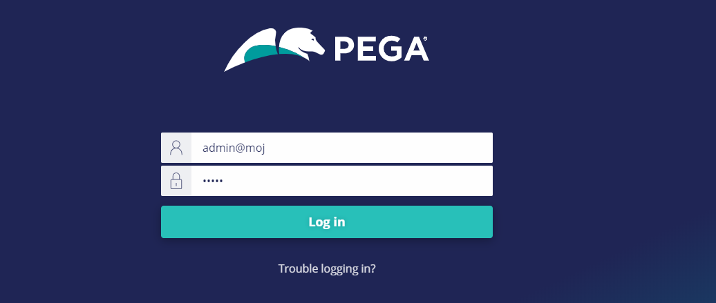

1. On logging below on the left pane click the Operator Icon and select Operator from the list

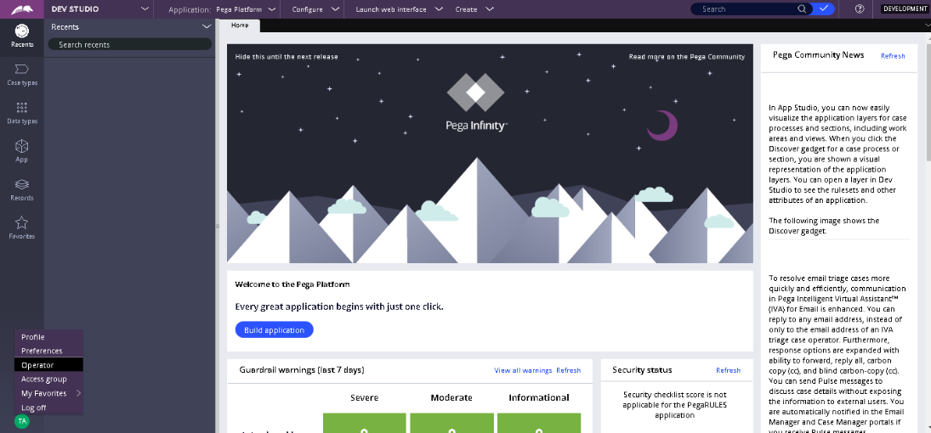

1. On operator landing page on right hand top corner click on arrow beside Save and Select Save as

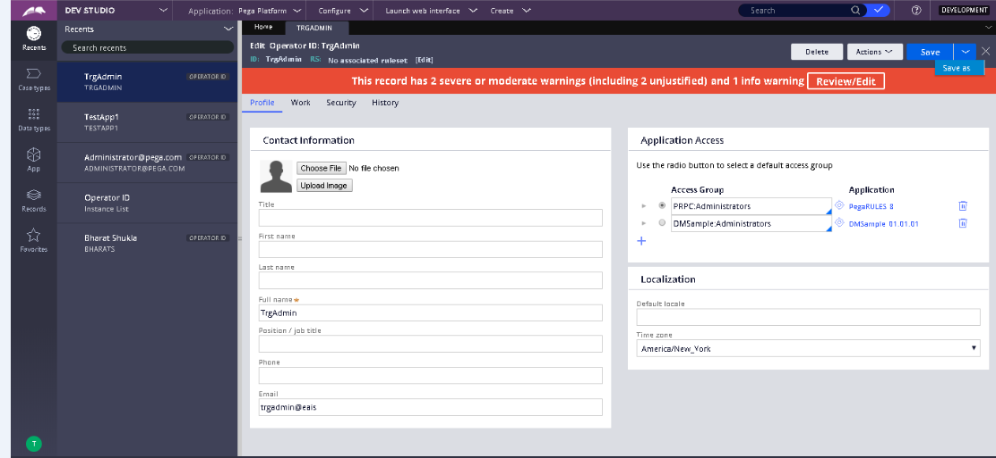

1. In Short Description enter Operator Name and In Operator ID enter as FirstName and LastName(1st and 2Initials)ex. DanielBr and click on Create and Open

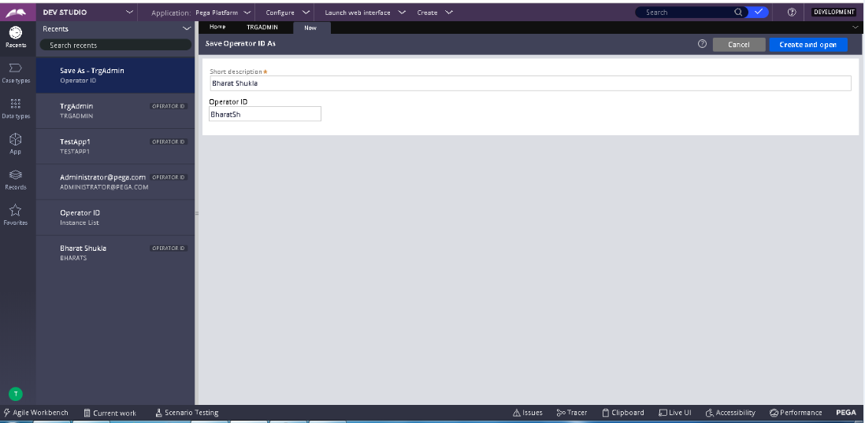

1. Enter the Full Name Email of Operator ID and click on Save on right hand side top of Screen

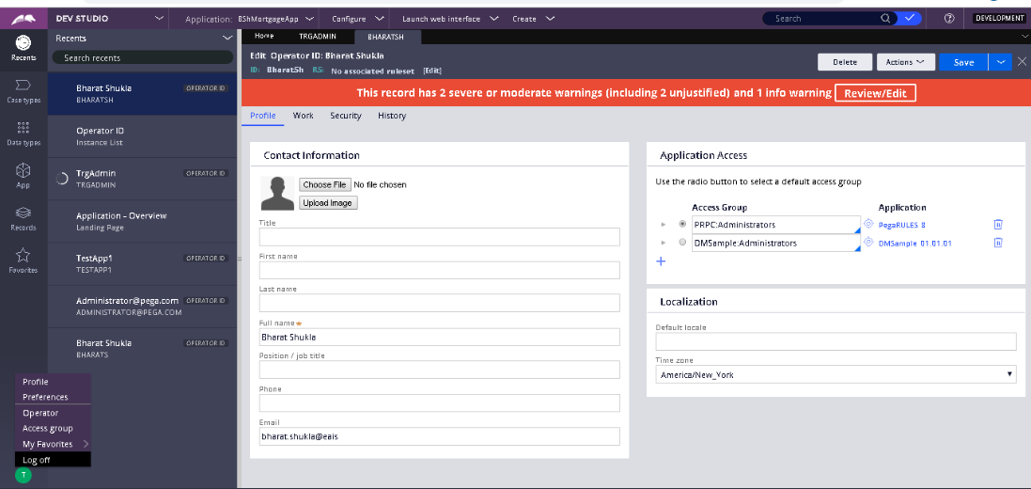

1. Now the operator can log in using the Operator ID as username and rules as password

## 2. Create New Application – Ministry of Justice

1 From the top navigation bar click on arrow beside Configure and select New Application

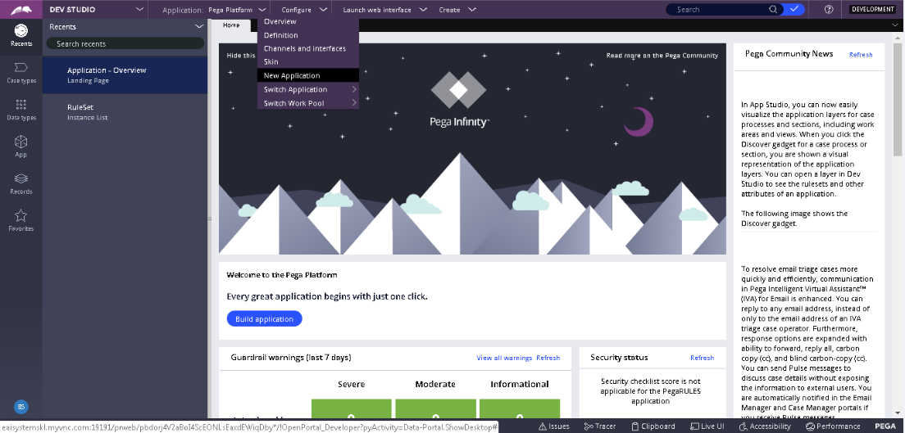

2 From the list of application types select Custom

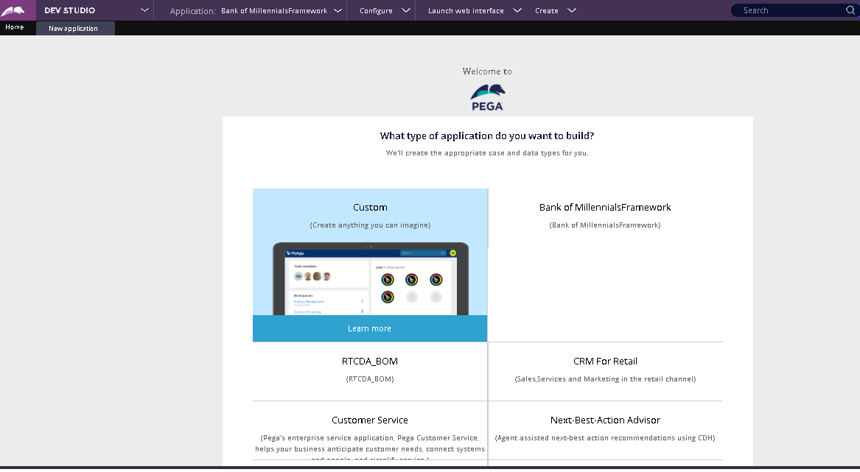

3 Then select Use this application type

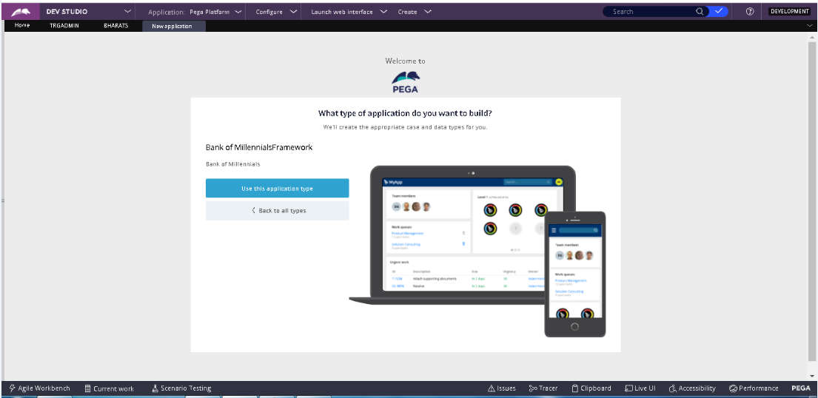

4 In Name your application field enter some valid application name and click on Create application

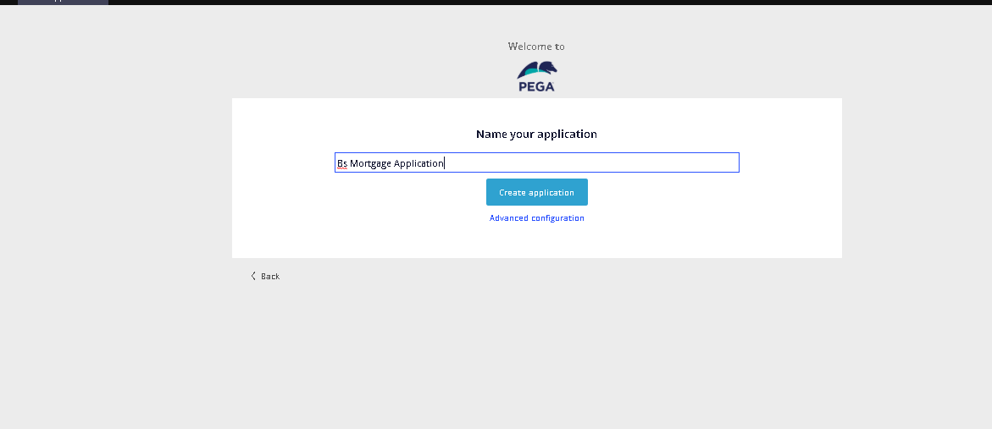

5 Click on Go to app.

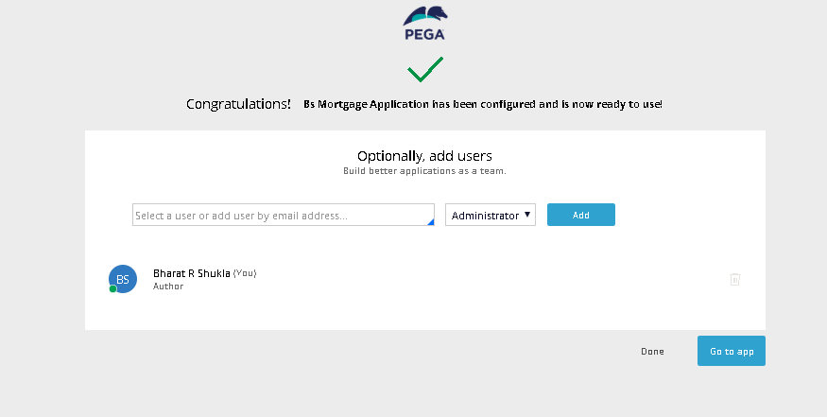

## Create case type – Ministry of Justice

|  |  |
| --- | --- |
|  | Creating a Case type in Pega |

1) Log in to App Studio as the provided credentials.

2) To toggle between studio modes in left use the top left option, click and switch. For now, we will toggle to App Studio.

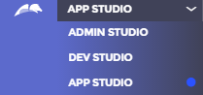

3) In App Studio, from the left navigation panel, click **Case types** to view the Case Type Explorer. A list of case types defined for your application is displayed.

4) From the Case Type Explorer, click **New** to open a dialog for creating a new case type.

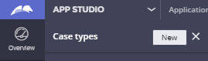

5) In the **Case type name** field, enter **Ministry of Justice** to provide a name for your case type.

And press Next.

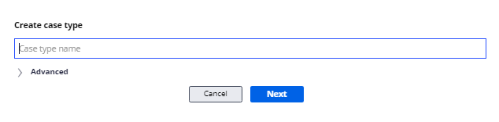

## 4. Design Case Process – Application stages

|  |  |
| --- | --- |
|  | Adding Stages to Case Type |

1. In the Ministry of Justice case type, click the **Workflow** tab to begin modeling the Ministry of Justice work flow

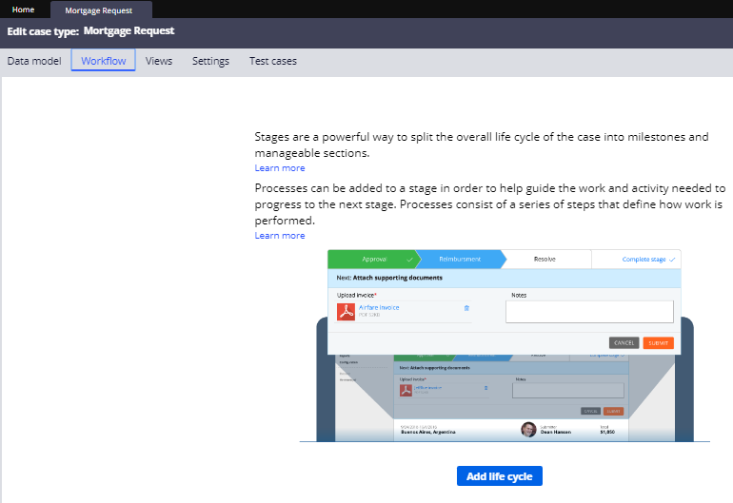

2.Click **Add life cycle**. A case life cycle with one stage is displayed.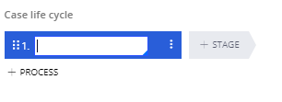

3.In the text field of the first stage, enter **Intake** as the name of the first stage.

4.In the contextual properties panel on the right, ensure that **Automatically move to next stage** is selected to advance the case automatically.

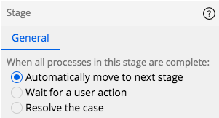

5.To the right of the Select Mortgage stage, click **+ STAGE** to create a second stage in the case life cycle.

6.In the empty stage name field, enter **Investigation** to name the second stage.

7.In the contextual properties panel on the right, ensure that **Automatically move to next stage** is selected to advance the case automatically.

8.To the right of the Intake stage, click + STAGE to create a third stage in the case life cycle.

9.In the empty stage name field, enter **Judgement Delivery** to name the third stage.

10. Click **Save** to save your progress on the Ministry of Justice work flow.

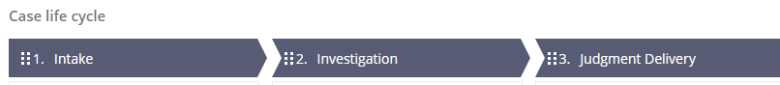

11. We need to add a Alternate stage named it as a Exception stage,

For that, click on 3 dots on case lifecycle, and select **Set as alternate stage**

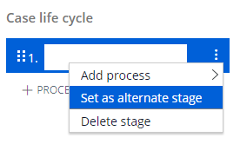

12. Exception stage will be added below the primary stages , check below picture



|  |  |
| --- | --- |
|  | Adding Process and Stages to Case Type |

1. Under the Intake stage, hover the pointer over  **+ PROCESS** and then click **+ STEP** to create a process with a single step in the stage.

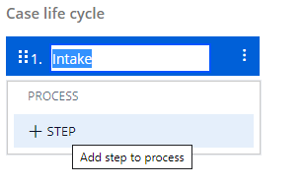

2.Select the **Multi-step form** step type to create a step to collect user input.

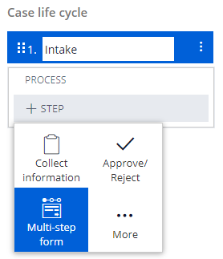

3.Type **Undertaking** as the name of the step.

4.Click **+ FORM STEP** to add a second step to the process and enter **Prosecutor’s Data** as the name of the step.

5.Under the **Intake stage** chevron, enter **File New Lawsuit** to change the name of the process.

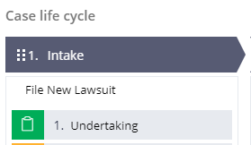

6. Click **+ FORM STEP** to add a third step to the process and enter **Defendant’s Data** as the name of the step.

7. Click **+ FORM STEP** to add a fourth step to the process and enter **The Claim Data** as the name of the step.

8. Click **+ FORM STEP** to add a fifth step to the process and enter **Case Attachments** as the name of the step.

9. Click on the Process, to open the process flow

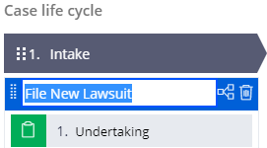

10. It will open the Multi-step form panel on the right hand side. From there, click on the **Open process**

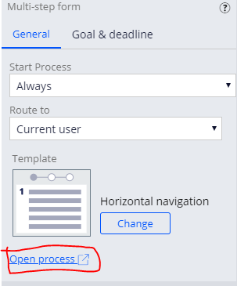

11. On the File New Lawsuit process, Right-click Add > Decision shape,

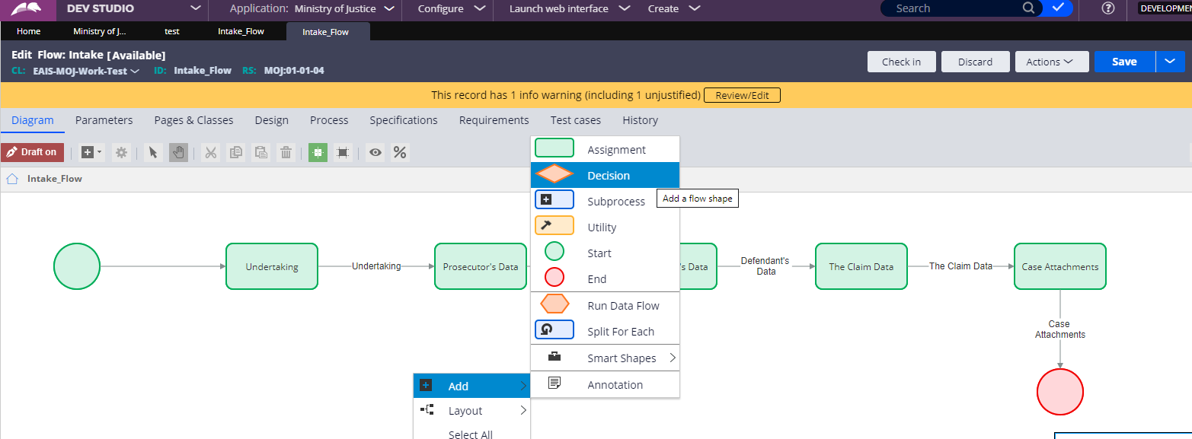

12. Right click on the Decision Shape, click on **View Properties,** and enter the label **Is Attached all the Documents?, Select Type as Fork,**  then click on submit. Also click on save after performing a single change.

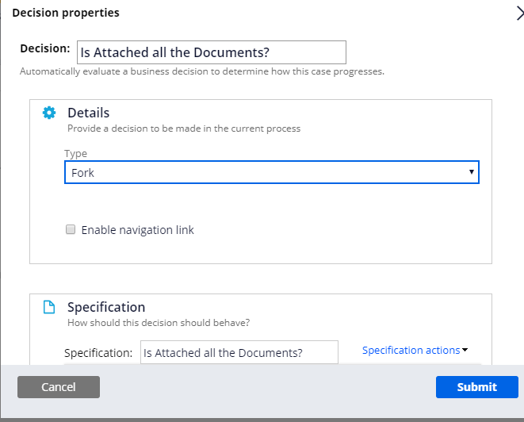

13. Connect Case attachment shape to Decision shape

14. Right-click Add > Assignment shape. Right click on the Assignment shape and enter the label as **Send to Court**

**15.** Right-click Add > Utility shape. Right click on the Utility shape and enter the label as **Change to a specific stage** and in the Stage dropdown select **Exception** stage and in the Audit note, enter **“Lawsuit cannot be filed due to lack of documents”**

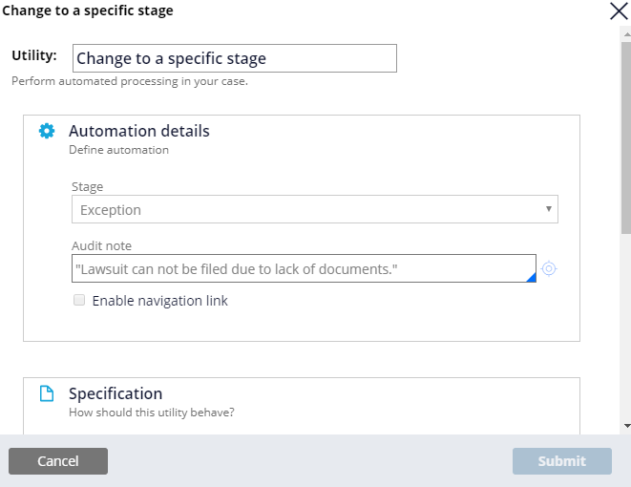

16. Connect one end of Decision shape to Send to Court Assignment and other end to Change to a specific stage.

17. Right-click Add >Utility shape. Right click on the Utility shape , click on View Properties and enter the label as **Send email to prosecutor,** then click on Submit

18**.** Right-click Add >Utility shape. Right click on the Utility shape , click on View Properties and enter the label as **Send email to Defendant,** then click on Submit

19.Right-click Add > Smart Shapes > Persist case shape. Connect **Undertaking** shape to **Persist** **case** and **Persist case** to **Prosecutor’s Data**

20. The whole process flow will look like this, after adding all shapes

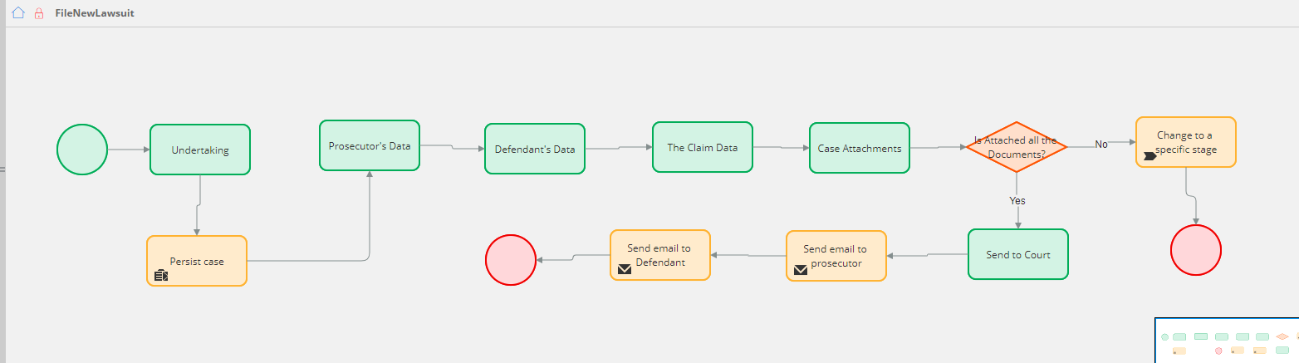

21. As shown in above flow, Open the Yes Connector by double clicking on it and enter the label as **Yes,** then click on submit. Now , open the No connector by double clicking on it, enter the label as **No,** then click on submit. Save the flow.

22. Connect each of the shapes with other shapes as shown in above Process flow , if missed something.

23. Now , do a check in by adding some comment in it. Check- in will save all your changes.

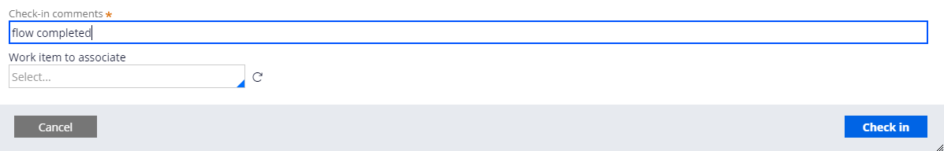

24. Go back to Workflow again and In the second stage **Investigation,** Open the process flow.

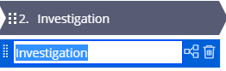

25. Right-click Add >Utility shape. Right click on the Utility shape, click on View Properties and enter the label as **Set Case Status,** then click on Submit.

26. Right-click Add >Assignment shape. Right click on the Assignment shape, click on View Properties and enter the label as **Investigation,** then click on Submit. Save the flow and do a check in by adding some comment in it.

27. Investigation Process flow will look like this,

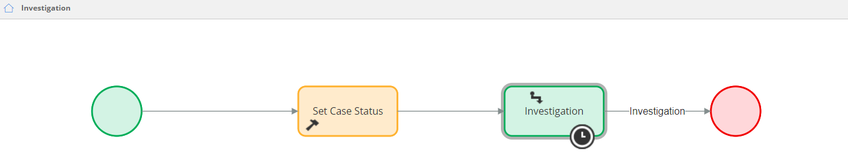

28. Now, Go back to Workflow, click on Investigation step and set the status as “Pending-Investigation”, check below image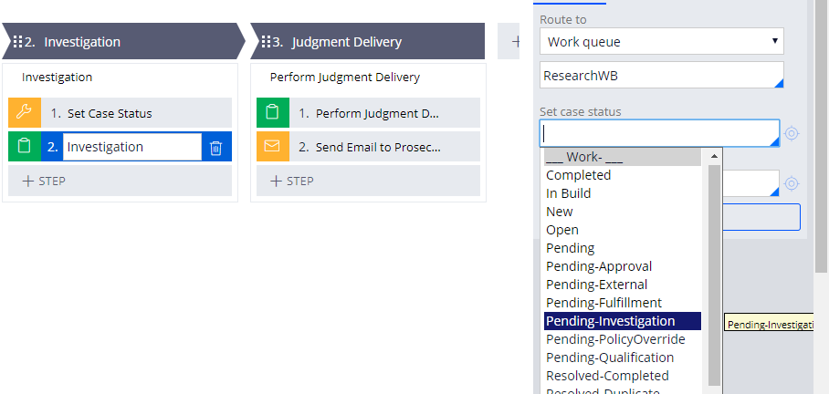

28. Now , Go back to WorkFlow, and in the third stage Judgement Delivery, under the **process Perform Judgement delivery**, hover the pointer over **+ PROCESS** and then click **+ STEP** to create a process with a single step in the stage.

29. Select the **Collect Information** step type to create a step to collect user input and rename it as **Perform Judgment Delivery**

30. Select **+ STEP > More > Automations > Send email > Select** to add to the process a step to send an email.

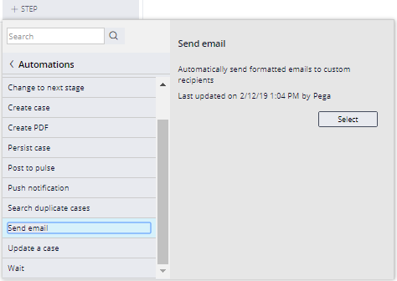

31.Click the **Send email** step and enter **Send Email to Prosecutor** as the name of the shape.

32. The stage will look like this,

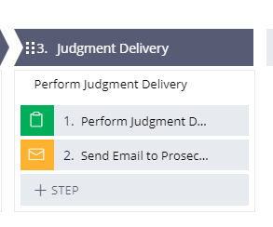

33. In the Workflow, there is an alternate stage called Exception, hover the pointer over **+ PROCESS** and then click **+ STEP** to create a process with a single step in the stage.

34. Select the **Collect Information** step type rename it as **Display Exception Message**

**35.** The whole workflow will look like below image,

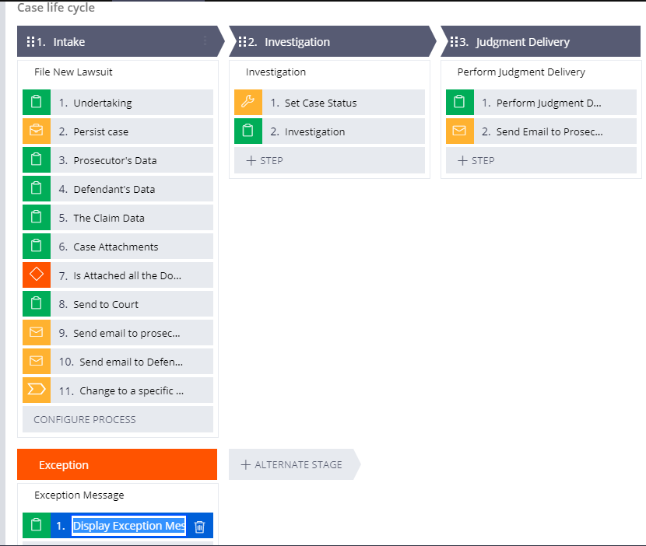

## 5.Build UI

|  |  |
| --- | --- |
|  | Configuring Data Model and UI : |

1. In **Designer Studio**, create a class called Address by clicking on the left side navigation panel, **Records Explorer>Sysadmin>Class>Right-click>Create**

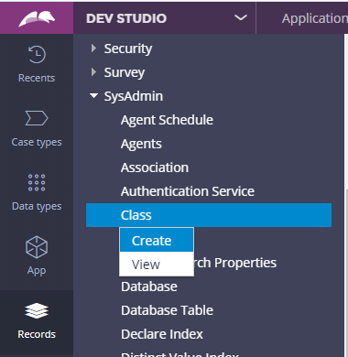

1. Follow below image to create the class, then click Create and Open

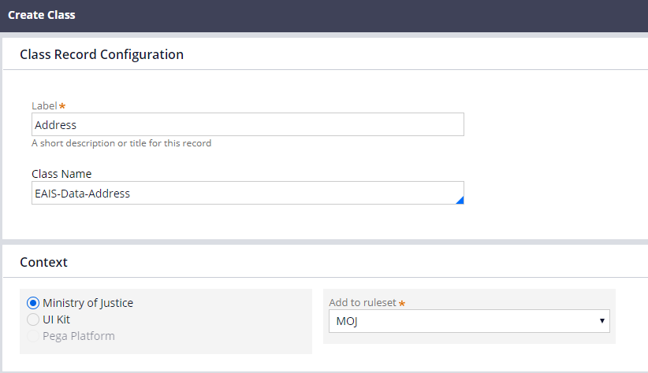

1. Select Class type as Abstract, version: 01-01-01, Parent Class: EAIS-Data., then click on Save
2. Now Create the following properties in EAIS-Data Class, in the Data Model tab.

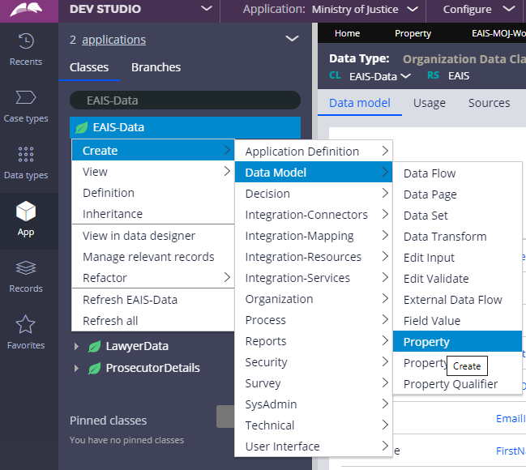

1. Enter label as First Name, Class: EAIS-Data, Ruleset: MOJ, Version: 01-01-01, then click on Create and Open.
2. Select UI control as Text input
3. Now once the single property is created, Right click on that property from Left Hand Navigation panel and click on Create properties.

**For eg: Age>Right-click > Create properties**

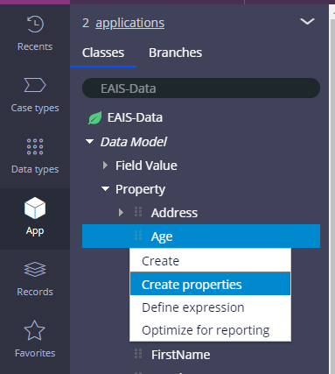

1. Now click on **+Add field**
2. In the empty field enter “Age” and set type as “Integer”.
3. Now click on **+Add field**
4. In the empty field enter “City” and set type as “Text (single line)”.
5. Now click on **+Add field**
6. In the empty field enter “Country” and set type as “Text (single line)”.
7. Now click on **+Add field**.
8. In the empty field enter “DateOfBirth” and set type as “Date only”.
9. Now click on **+Add field**.
10. In the empty field enter “Email ID” and set type as “Text (single line)”.
11. Now click on **+Add field**
12. In the empty field enter “Gender” and set type as “Text (single line)”.
13. Now click on **+Add field**
14. In the empty field enter “HouseNumber” and set type as “Text (single line)”.
15. Now click on **+Add field**
16. In the empty field enter “Landmark” and set type as “Text (single line)”.
17. Now click on **+Add field**
18. In the empty field enter “LastName” and set type as “Text (single line)”.
19. Now click on **+Add field**
20. In the empty field enter “MiddleName” and set type as “Text (single line)”.
21. Now click on **+Add field**
22. In the empty field enter “MiddleName” and set type as “Text (single line)”.
23. Now click on **+Add field**
24. In the empty field enter “PhoneNumber” and set type as “Integer”.
25. Now click on **+Add field**
26. In the empty field enter “PinCode” and set type as “Text (single line)”.
27. Now click on **+Add field**
28. In the empty field enter “State” and set type as “Text (single line)”.
29. Now click on **+Add field**
30. In the empty field enter “Street” and set type as “Text (single line)”.
31. Now click on **+Add field**
32. In the empty field enter “Address” and set type as “Field group”, specify Data Type as “EAIS-Data-Address”
33. Click on Save
34. Now Following properties will be created in Casetype Data model tab,

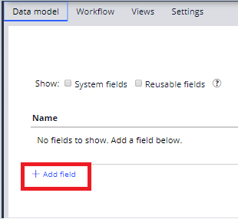

1. Now click on **+Add field**
2. In the empty field enter “Pledge” and set type as “Text (single line)”.
3. Following properties will be created in EAIS-MOJ-Work-MinistryOfJustice class:
4. Property Name: CourtDate, Datatype: Date
5. Property Name: NextDate, Datatype: Date
6. Property Name: CaseDetails, Datatype: Single Page, Specify Class: EAIS-MOJ-Data-CaseInformationDetails (if this class not present, please do create the class)
7. Property Name: CaseInformation, Datatype: Text
8. Property Name: CriminalCaseTypes, Datatype: Text, Table type: Local List, Table values: 1. Fraud 2. Dowry Harassment
9. Property Name: IsSubmittedAllTheDocs, Datatype: Text, Table type: Local List, Table values: 1. Yes 2. No
10. Property Name: LawyersData, Datatype: Single Page, Specify Class: EAIS-Data-LawyerData (if this class not present, please do create the class)
11. Property Name: IsHiredAnyLawyer, Datatype: Text, Table type: Local List, Table values: 1. Yes 2. No
12. Property Name: CivilCaseType, Datatype: Text, Table type: Local List, Table values: 1. Divorce 2. Domestic Violence Case
13. Property Name: CaseType, Datatype: Text, Table type: Local List, Table values: 1. Criminal Case 2. Civil Case
14. Property Name: DefendantDetails, Datatype: Single Page, Specify Class: EAIS-Data-DefendantDetails (if this class not present, please do create the class)
15. Property Name: ProsecutorDetails, Datatype: Single Page, Specify Class: EAIS-Data-ProsecutorDetails (if this class not present, please do create the class)
16. Property Name: CaseNumber, Datatype: Text, Class: EAIS-Int-FetchCaseDetails

**Sections:**

1. **PerformUndertaking:**
2. Create a section called PerformUndertaking in Class EAIS-MOJ-Work-MinistryOfJustice, Ruleset: MOJ, Version: 01-01-01

**Records 🡪 User Interface 🡪 Section 🡪 Right click on Section 🡪 Create**

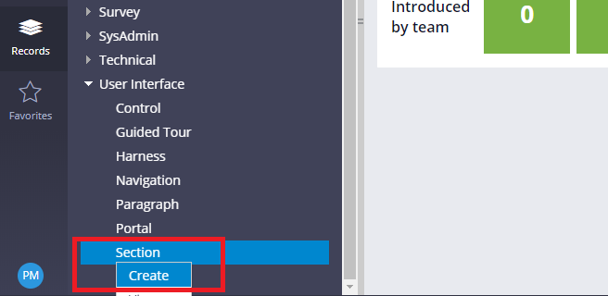

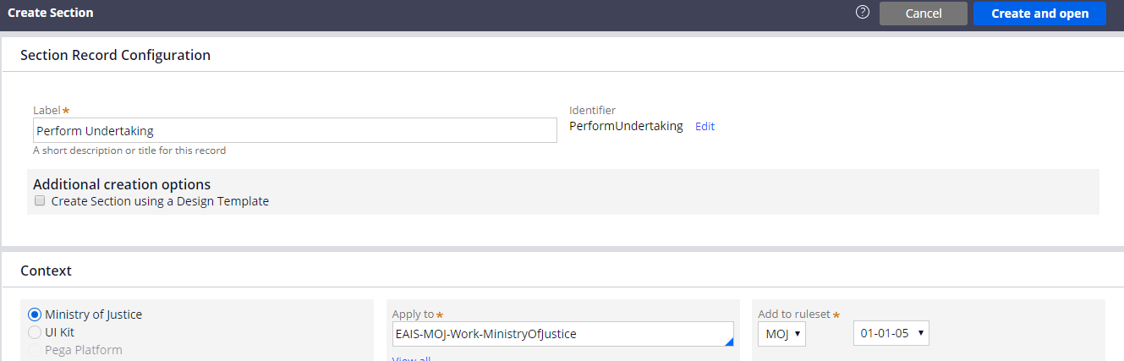

1. Drag a Dynamic Layout, from the Layout

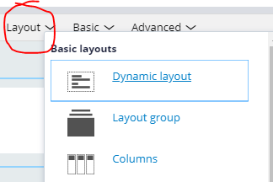

1. Open the Gear icon of Dynamic layout to configure Dynamic Layout Properties



1. Layout Format: Header Details, Container Format: Default.

Under the Container Settings: Title: Field Value (Undertaking), Heading level: Heading 2, Icon type: Standard Icon, Icon: cmicons/pycreate.svg, Icon Title: Undertaking

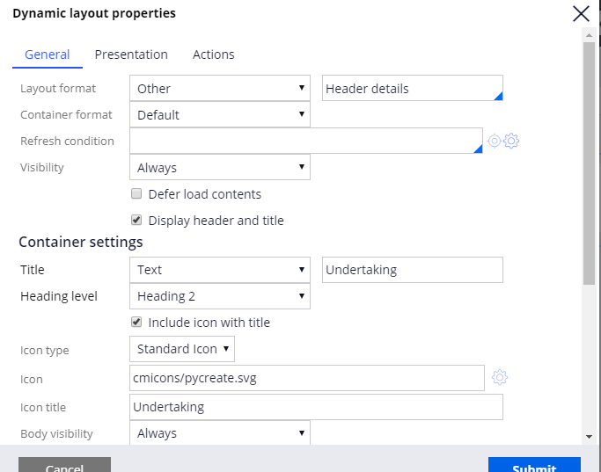

1. From the Advanced category, drag the Checkbox and open the Gear icon of it to add the properties,
2. Need to create the FieldValue: Pledge, Class: EAIS-MOJ-Work-MinistryOfJustice, Ruleset: MOJ, Version: 01-01-01
3. In To, Specify: I pledge to record all the information correctly according to the official documents, and I certify that I have never submitted the subject of this lawsuit to any judicial authority, and that my lawsuit is not fake or malicious and I bear full responsibility if proven otherwise.

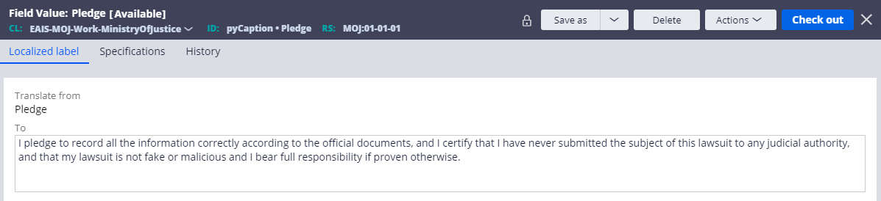

1. Now go to the PerformUndertaking section , open the checkbox, and add .Pledge in the proprety, and Pledge in the Caption

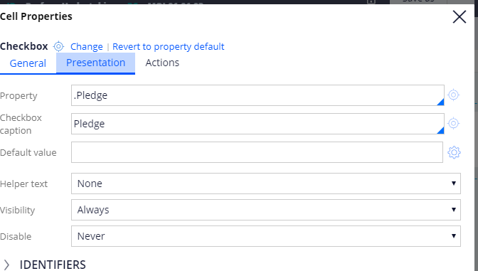

1. At the end, PerformUndertaking section will look like this:

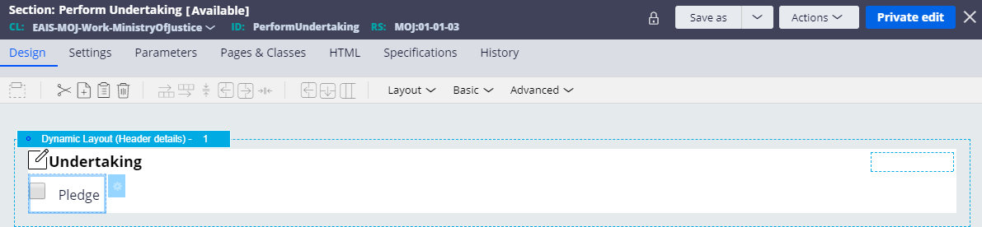

1. **EnterProsecutorsData section**
2. Create a section called **EnterProsecutorsData** in Class EAIS-MOJ-Work-MinistryOfJustice, Ruleset: MOJ, Available Version
3. To complete this section, we need to configure 2 sections in 2 different classes, and then will incorporate both into **EnterProsecutorsData section**
4. Create a section called **EnterPersonDetails** in Class EAIS-Data, Ruleset: MOJ, Available Version
5. Drag a Dynamic Layout, open it and make Layout format as Inline grid triple, click submit
6. Drag a Text Input from Basic, open it to configure.

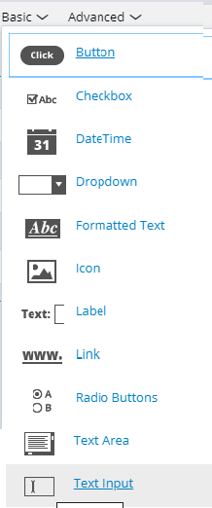

1. Add. FirstName property, and label as First Name
2. Perform step 5, and add. MiddleName, Label as Middle Name
3. Perform step 5, and add. LastName, Label as Last Name
4. Perform step 5, and add. Age, Label as Age
5. Perform step 5, and add. EmailID, Label as Email ID
6. Perform step 5, and add. PhoneNumber, Label as Phone number
7. Drag a DateTime from Basic, open it to configure, add. DateOfBirth, label as Date of Birth
8. Drag a Radiobutton, add. Gender as Property, and label as Gender
9. The whole section will look like this,

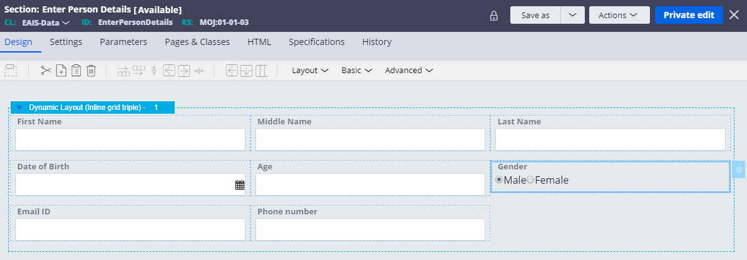

1. Create a section called EnterAddressDetails in Class: EAIS-Data-Address, Ruleset: MOJ and available version
2. Drag a Dynamic Layout, open it and make Layout format as Inline grid triple, FieldValue as Address, click submit
3. Drag a Text Input from Basic, open it to configure.
4. Add. HouseNumber property, and label as House Number
5. Perform Step 17, and add. Street, label as Street
6. Perform Step 17, and add. Landmark, label as Landmark
7. Perform Step 17, and add. City, label as City
8. Perform Step 17, and add. State, label as State
9. Perform Step 17, and add. PinCode, label as PinCode
10. Drag a Dropdown, and add. Country as Property, label as Country
11. Also Specify the following details, check below screenshot

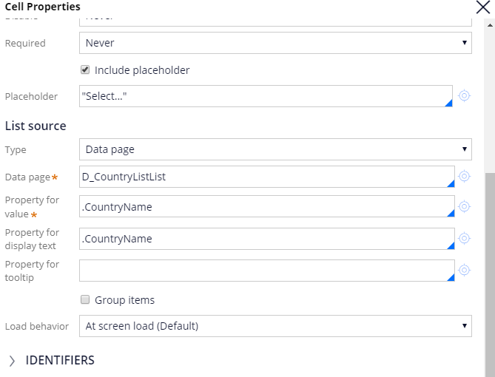

1. Whole EnterAddressDetails, will look like this,

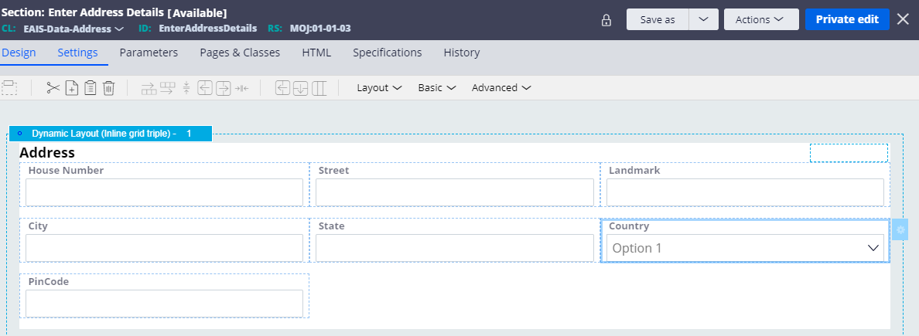

1. Now, incorporate these 2 sections in EnterProsecutor’sData section

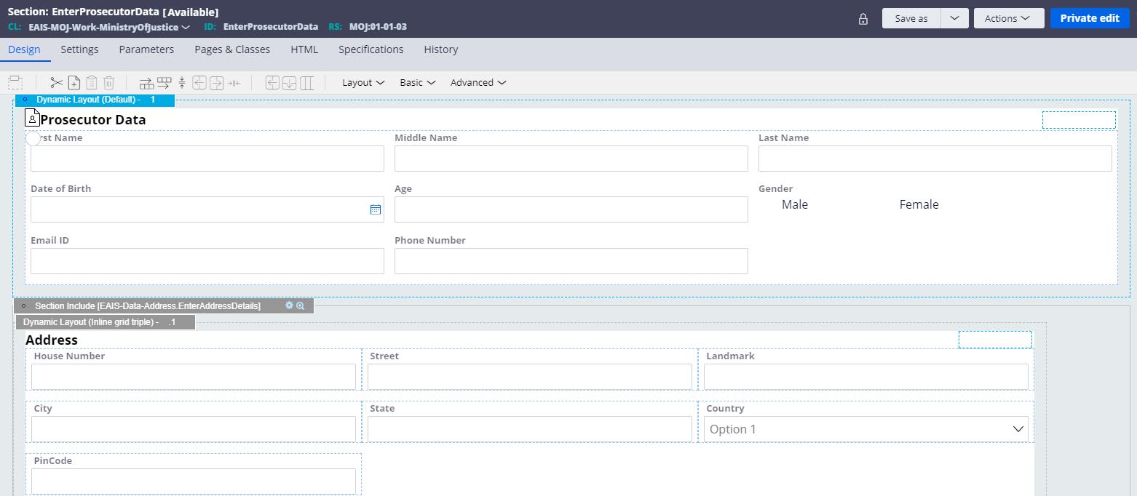

1. **EnterDefendantDetails section**
2. Create a section called **EnterDefendantDetails** in Class EAIS-MOJ-Work-MinistryOfJustice, Ruleset: MOJ, Available Version
3. **Incorporate EnterAddressDetails and EnterPersonDetails into EnterDefendantDetails**

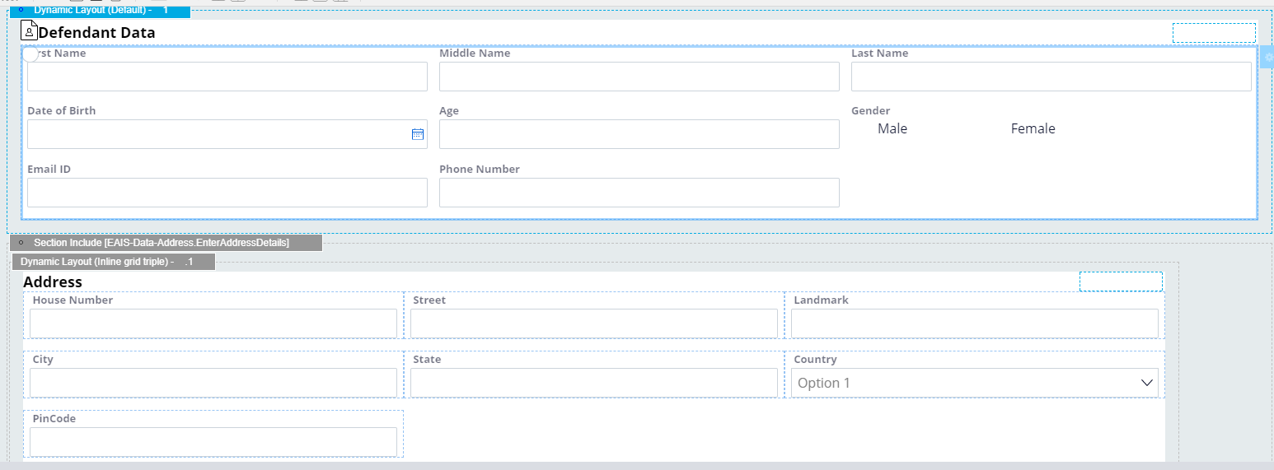

1. **EnterLawyersData Section:**
2. Create a section called **EnterLawyersData** in Class EAIS-Data-LawyerData, Ruleset: MOJ, Available Version
3. Drag a Dynamic Layout, open it and make Layout format as Inline grid triple, click submit
4. Drag a Text Input from Basic, open it to configure.
5. Add FirstName property, and label as First Name
6. Add MiddleName and label as Middle Name
7. Add LastName and label as Last Name
8. Add EmailID and label as Email ID
9. Add PhoneNumber and label as Phone number
10. The whole section will look like this,

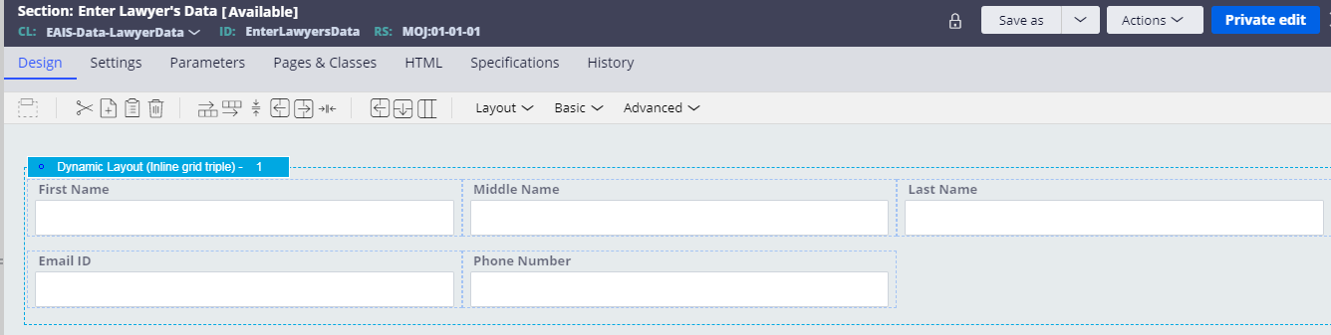

1. **EnterCaseDetails Section:**
2. Drag a Dynamic Layout, open it and make Layout format as Default, FieldValue as Case Data, Container Format as Default, click submit.
3. Drag a Dropdown, and add. CaseType as Property, label as CaseType, select include placeholder checkbox and on Placeholder field, specify "Select..."
4. Drag a Dropdown, and add. CriminalCaseTypes as Property, label as CriminalCaseTypes, select Visibility condition as Condition (expression), add Condition for visibility as. CaseType=='Criminal Case' , select checkbox Run visibility condition on client ,select include placeholder checkbox and on Placeholder field, specify "Select..."
5. Drag a Dropdown, and add. CivilCaseType as Property, label as CivilCaseType, select Visibility condition as Condition (expression), add Condition for visibility as. CaseType=='Civil Case’, select checkbox Run visibility condition on client, select include placeholder checkbox and on Placeholder field, specify "Select..."
6. Drag a Dynamic Layout, open it and make Layout format as Inline grid triple, Container Format as MOJ Default, click submit.
7. Drag a Text Area from Basic, open it to configure.
8. Add. CaseInformation, and label as CaseInformation
9. Drag a Dynamic Layout, open it and make Layout format as Inline grid double, Container Format as MOJ Default, click submit.
10. Drag a label from Basic Category and open it to configure, specify value as Have you hired any lawyer, select Visibility as Always.
11. Drag a Radio Buttons, and add. IsHiredAnyLawyer as Property. Add event action on Actions tab, select change as an event, add Post value as an Action
12. Drag a Dynamic Layout, open it and make Layout format as Default, Container Format as MOJ Default, select Visibility as Condition (expression), specify condition as. IsHiredAnyLawyer=='Yes', add Field value as Lawyer Information, click submit.
13. Select a label from Basic Category and open it to configure, specify value as Please enter your lawyer information below, select Visibility as Always.
14. Select an Embedded section from Layout category and enter the following details, please refer the below image, it will incorporate EnterLawyersData into this section

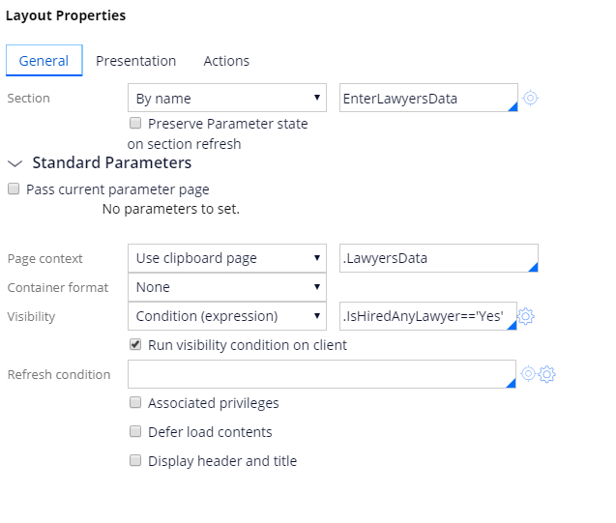

1. **The whole section will look like this,**

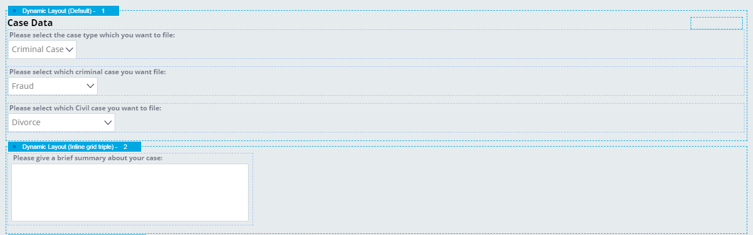

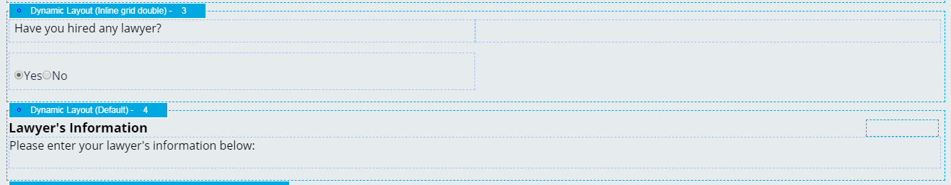

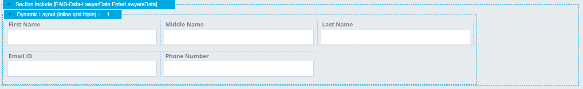

1. **AttachDocuments Section**
2. Drag a Dynamic Layout, open it and make Layout format as Default, Container Format as Default, click submit.
3. Drag a label from Basic Category and open it to configure, specify value as Please Attach all the required documents, select Visibility as Always.
4. Drag a Text Input from the Basic Category, open it to configure, select different control by clicking on Change,

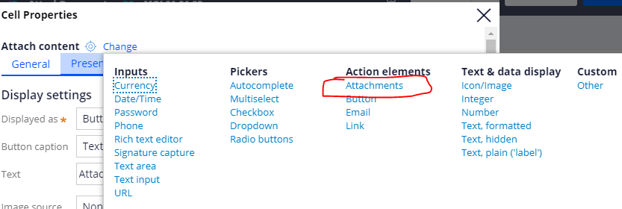

Select Displayed as Button, Button Caption as Text, specify Text as Attach Content

Configure below screenshot for other configurations

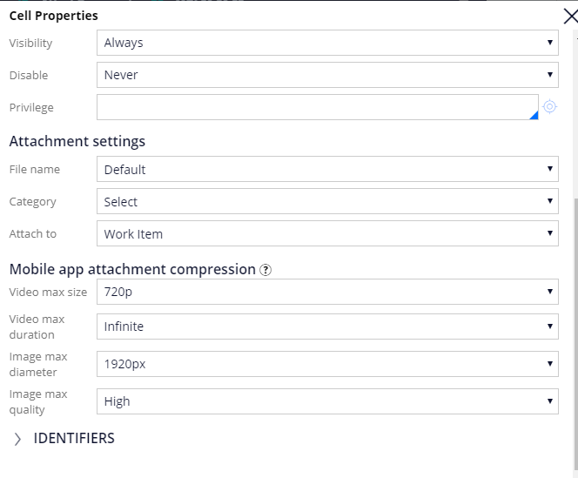

1. Drag a Table Layout from Layout category, open it to configure, select source as Property, and List/Group as .pyCaseRelatedContent. On Presentation tab, select Style as MOJ Grid Default, select Container Format as MOJ Default 2. On Header Settings section, select Field Value as Attached Documents, select checkbox Include Icon with title, icontype as Standard Icon, specify “cmicons/pyUploadDocument.png” on icon field. Header type will be Bar.
2. Drag a Dynamic Layout and open it to configure, select Layout Format as Inline grid double, Container Format as MOJ Default
3. Drag a label from Basic Category, open it to configure, specify value as Have you attached all the required documents, select Visibility as Always
4. Select Radio Buttons from the Basic Category, and open it to configure, specify .IsSubmittedAllTheDocs as a Property field. Add event action on Actions tab, select change as an event, add Post value as an Action.
5. The whole section will look like this,

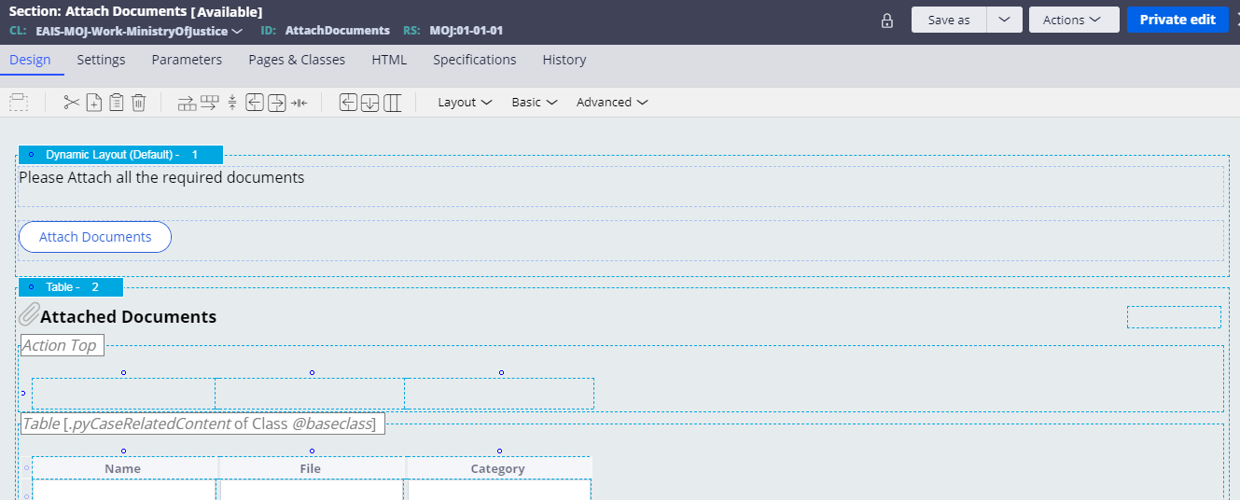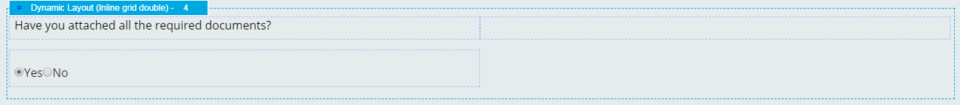

## 6. Data Transform

|  |  |
| --- | --- |
|  | Add a data transform to the case type |

1. Open pyDefault Data transform,

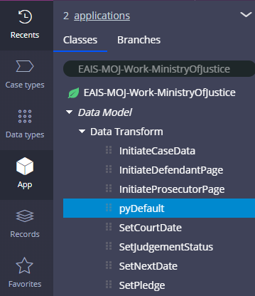

1. Set .pxUrgencyWorkClass equal to 10.

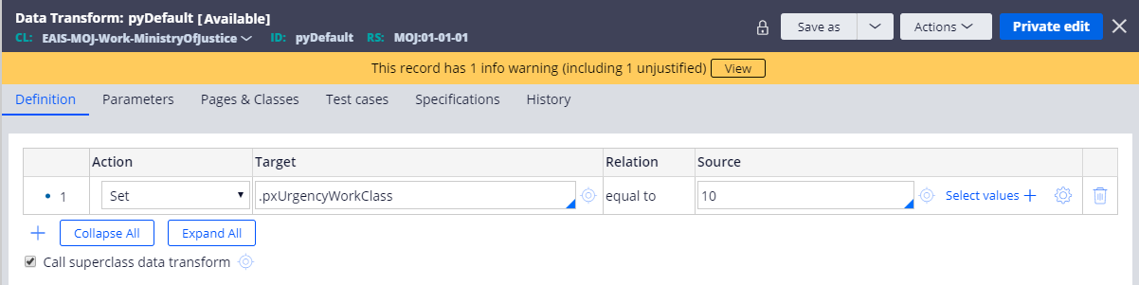

1. Create **SetPledge** DTin class EAIS-MOJ-Work-MinistryOfJustice, Ruleset: MOJ, Version: 01-01-01
2. Set .Pledge equal to “”

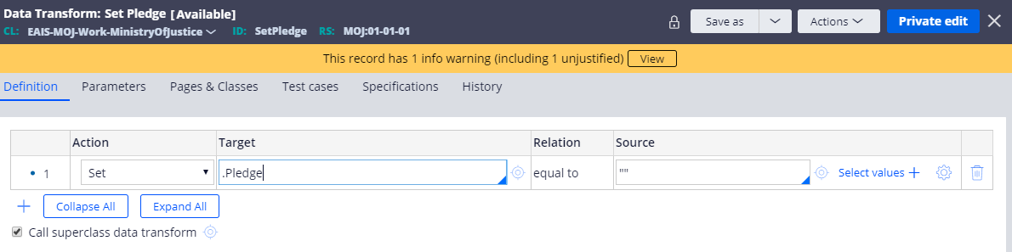

1. Apply SetPledge Data Transform, in **PerformUndertaking** Flow Action, under Action tab in the Pre-processing section

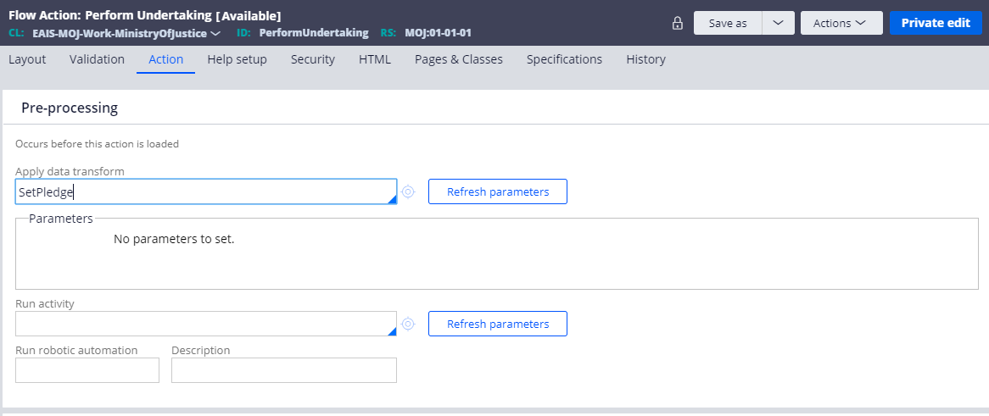

1. Create **SetNextDate** DTin class EAIS-MOJ-Work-MinistryOfJustice, Ruleset: MOJ, Version: 01-01-01
2. Set .NextDate equal to @(PegaRULES:BusinessCalendar).addDays(.CourtDate,5,true,OperatorID.pyCalendar)

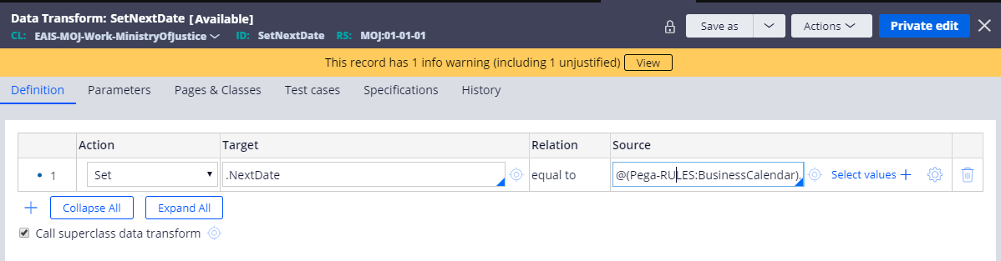

1. **Apply SetNextDate** DT in **Investigation** Flow Action, under Action tab in Pre-processing section

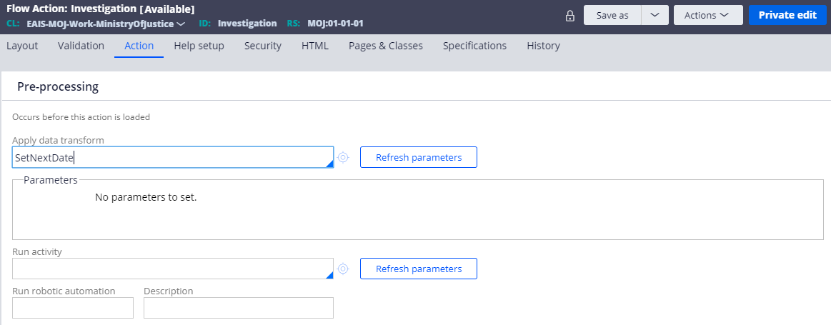

1. Create **InitiateCaseData** DTin class EAIS-MOJ-Work-MinistryOfJustice, Ruleset: MOJ, Version: 01-01-01
2. Set .LawyersData.pyLabel equal to “”

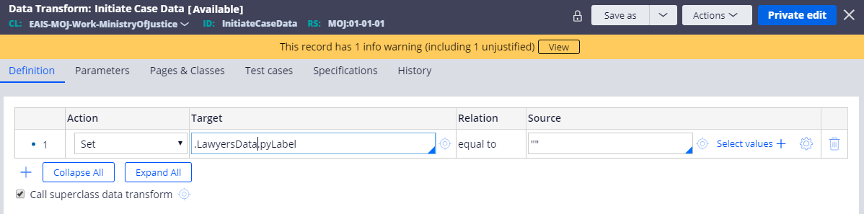

1. Apply **InitiateCaseData DT in EnterCaseDetails** Flow Action, under Action tab in Pre-processing section

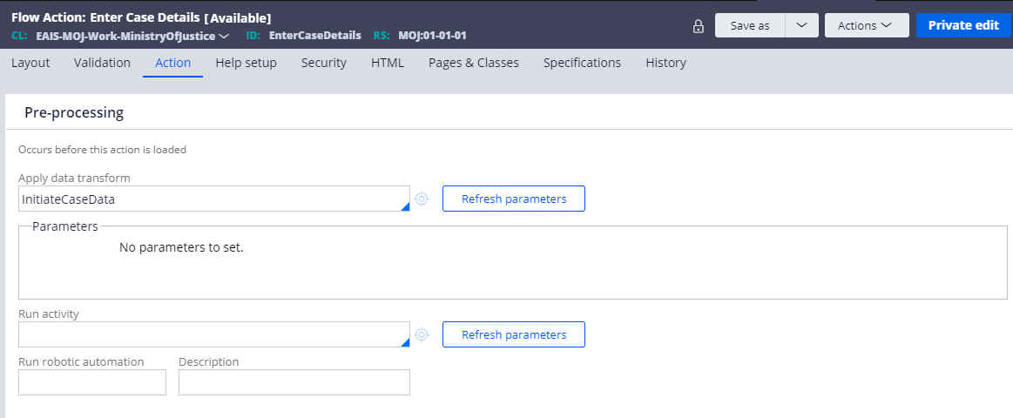

1. Create **InitiateDefendantPage** DTin class EAIS-MOJ-Work-MinistryOfJustice, Ruleset: MOJ, Version: 01-01-01
2. Set .DefendantDetails.Address.pyLabel equal to “”, .DefendantDetails.pyLabel equal to “”

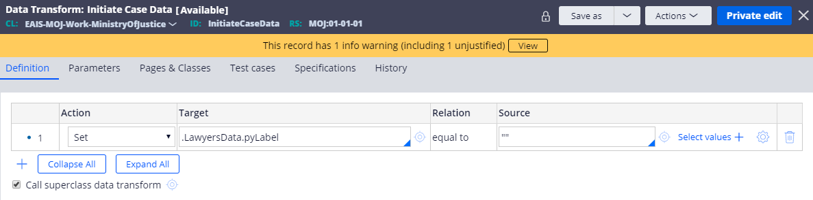

1. Apply **InitiateDefendantPage DT in EnterDefendantDetails** Flow Action, under Action tab in Pre-processing section

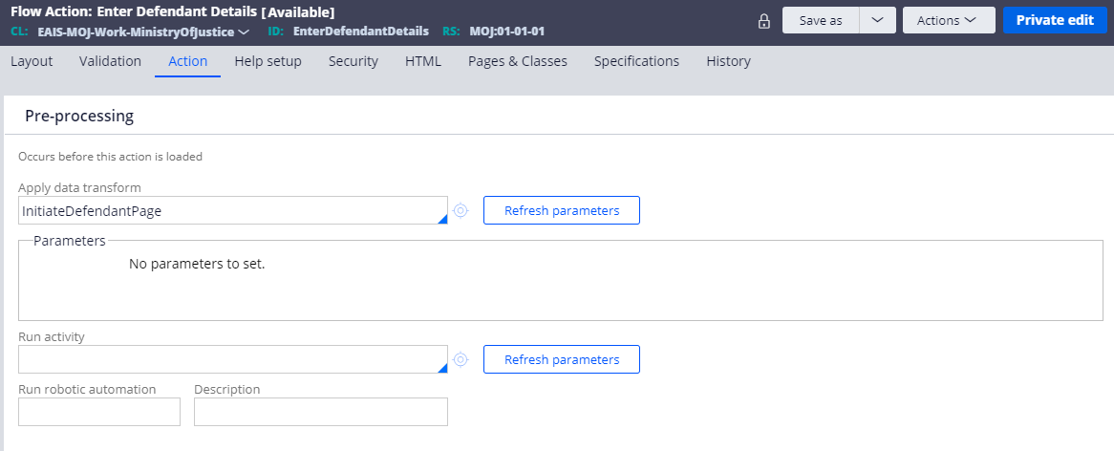

1. Create **InitiateProsecutorPage** DTin class EAIS-MOJ-Work-MinistryOfJustice, Ruleset: MOJ, Version: 01-01-01
2. Set .ProsecutorDetails.Address.pyLabel equal to “”, .ProsecutorDetails.pyLabel equal to “”

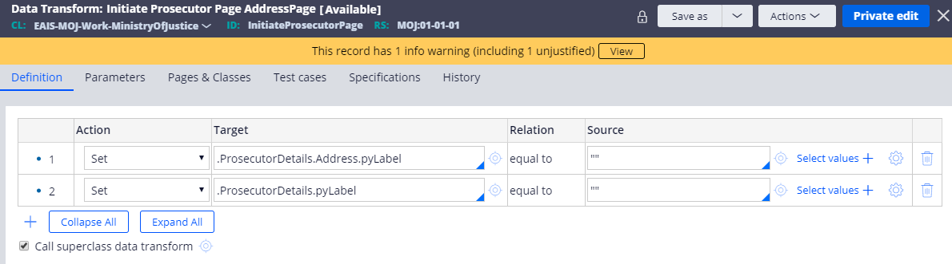

1. Apply **InitiateProsecutorPage DT in EnterProsecutorsData** Flow Action, under Action tab in Pre-processing section

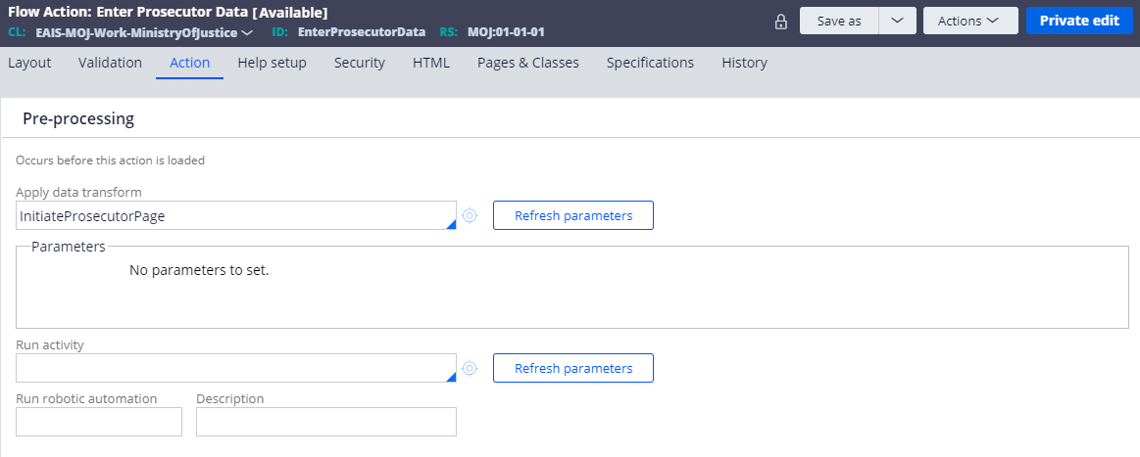

1. Create **SetCourtDate** DTin class EAIS-MOJ-Work-MinistryOfJustice, Ruleset: MOJ, Version: 01-01-01
2. Set .CourtDate equal to **@(Pega-RULES:BusinessCalendar).addDays(@CurrentDateTime(),5,true,OperatorID.pyCalendar)**

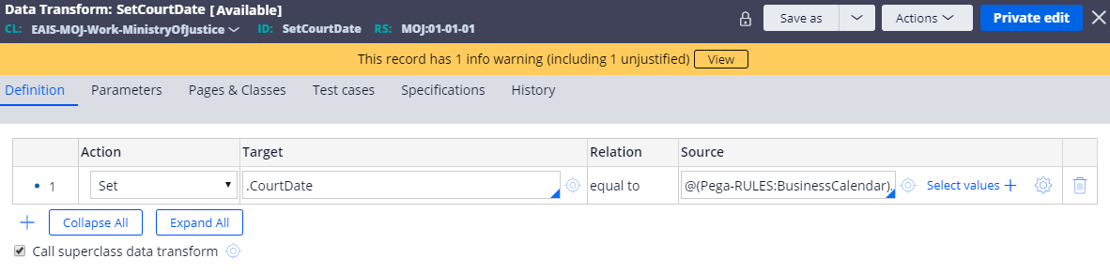

1. Apply **SetCourtDate DT in ConfirmDetailsAndSendToCourt** Flow Action, under Action tab in Pre-processing section

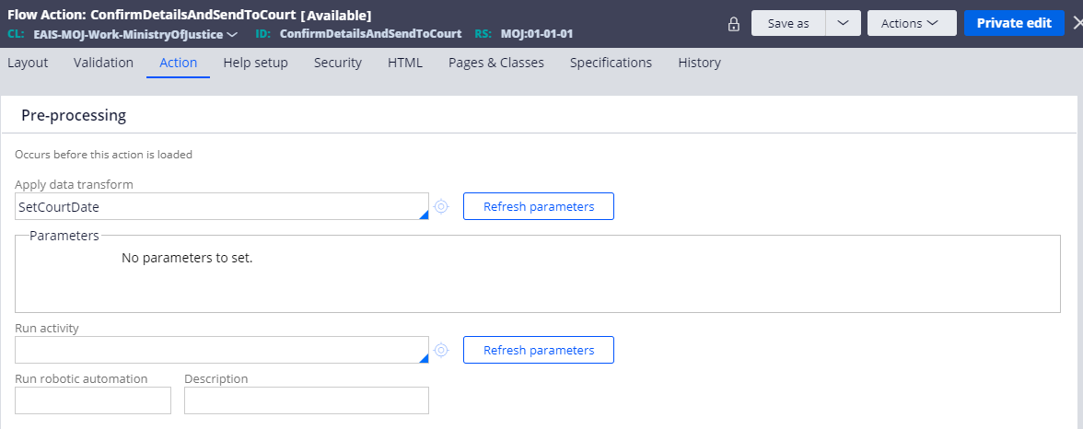

1. Create **SetJudgementStatus** DTin class EAIS-MOJ-Work-MinistryOfJustice, Ruleset: MOJ, Version: 01-01-01
2. Set .pyStatusWork equal to "Judgement-Passed"

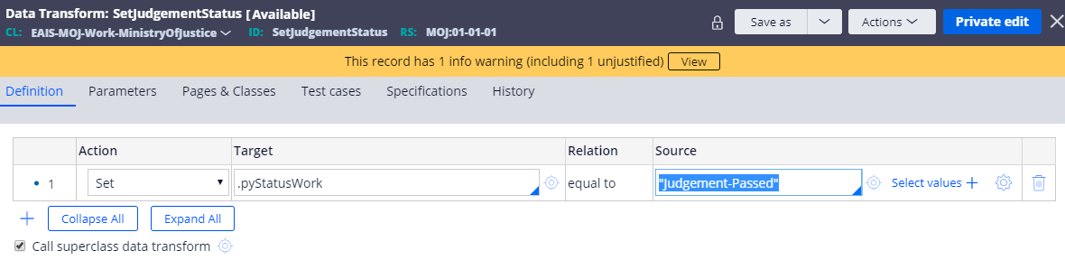

1. Apply **SetJudgementStatus DT in PerformJudgementDelivery** Flow Action, under Action tab in Pre-processing section

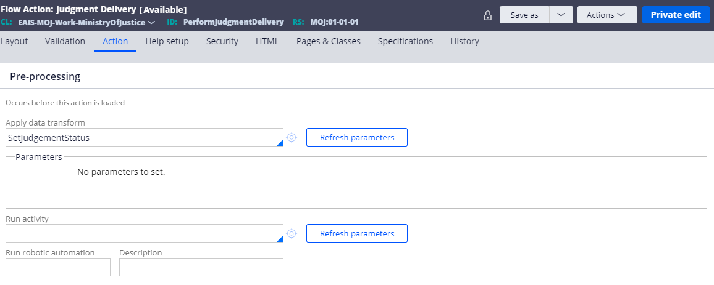

## 7.Add Service Level Agreement

|  |  |
| --- | --- |
|  | Add a service level agreement to the case type |

1. In **Designer Studio**, from the left navigation panel, open App explorer, under **Ministry of Justice** case type, Right-click on the Process category, **Process>Create>Service Level Agreement :**

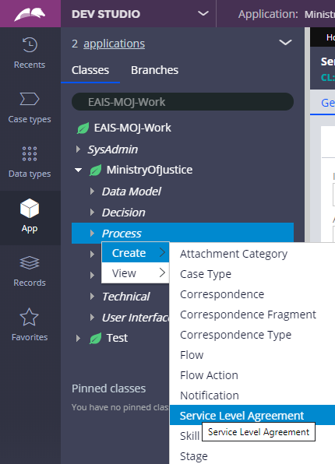

2. Specify the label as **NotifyJudge**, class as **EAIS-MOJ-Work-MinistryOfJustice,** selectRuleset **as MOJ,** and **available version.**

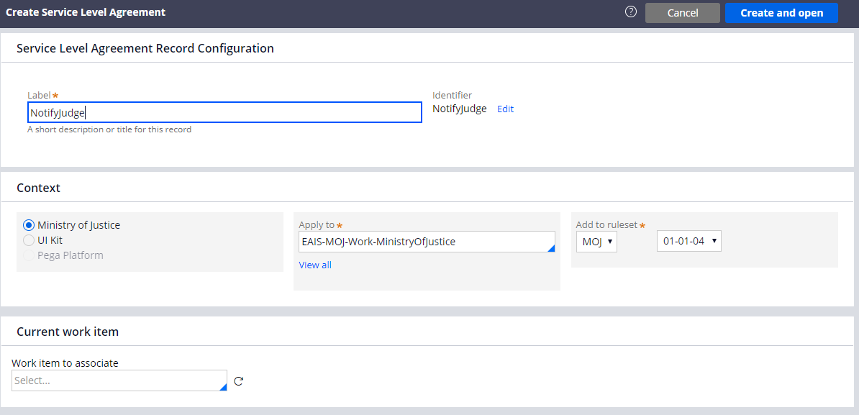

1. Under Start of service level, set Initial Urgency 10 and in Assignment Ready dropdown, select Immediately.
2. Under Service level definitions, in Calculate service levels dropdown, select **Interval from when assignment is ready**
3. On **Goal & Deadline** panel,

Under **Goal**, enter the following values:

* In the **Days** field, enter 5.
* In the **Hrs** field, enter 0, in the **Mins** field enter 0, in the Secs field enter 0.
* In the **Amount to increase** **urgency** field, enter 50.
* Select checkbox, **Only calculate using business days**

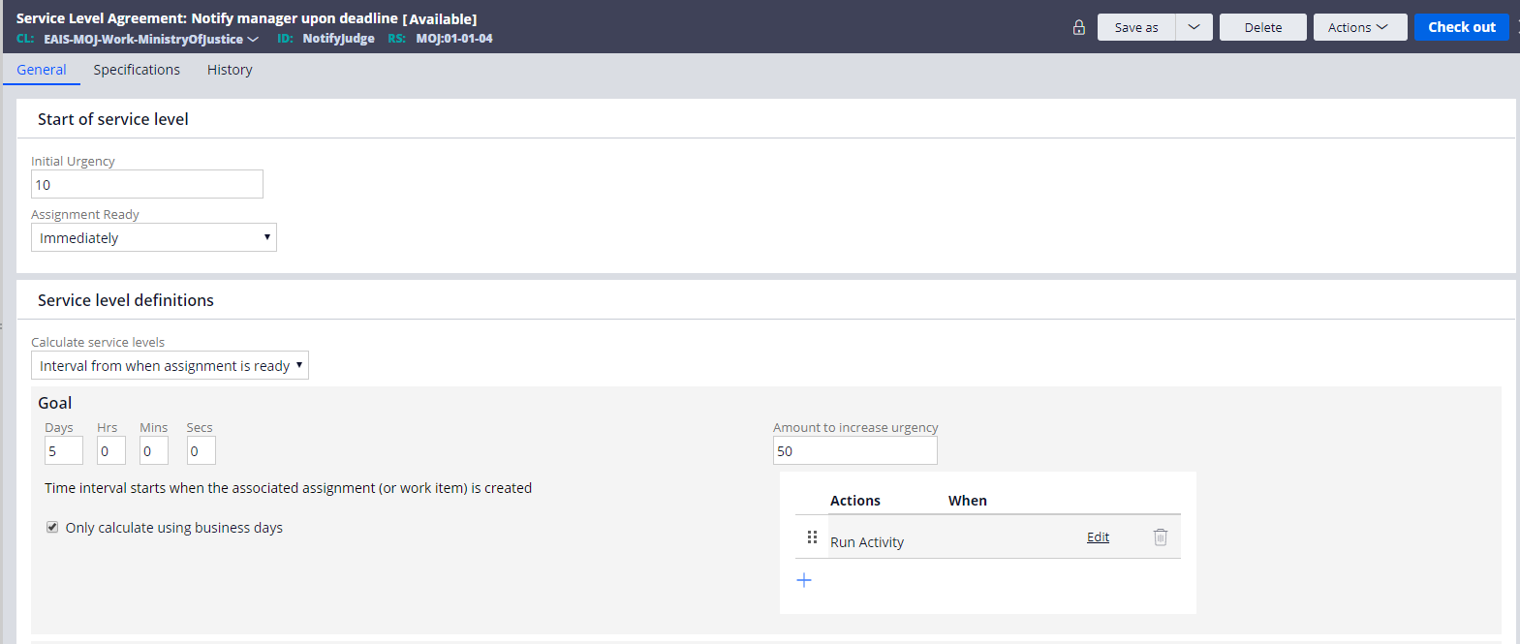

Under **Deadline**, enter the following values:

* In the **Days** field, enter 10.
* In the **Hrs** field, enter 0, in the **Mins** field enter 0, in the Secs field enter 0.
* In the **Amount to increase** **urgency** field, enter 0.
* Select checkbox, **Only calculate using business days**
* Under Actions, select Run Activity, under Parameters, select Activity Name **SendEmailToJudge**
* Save the rule.

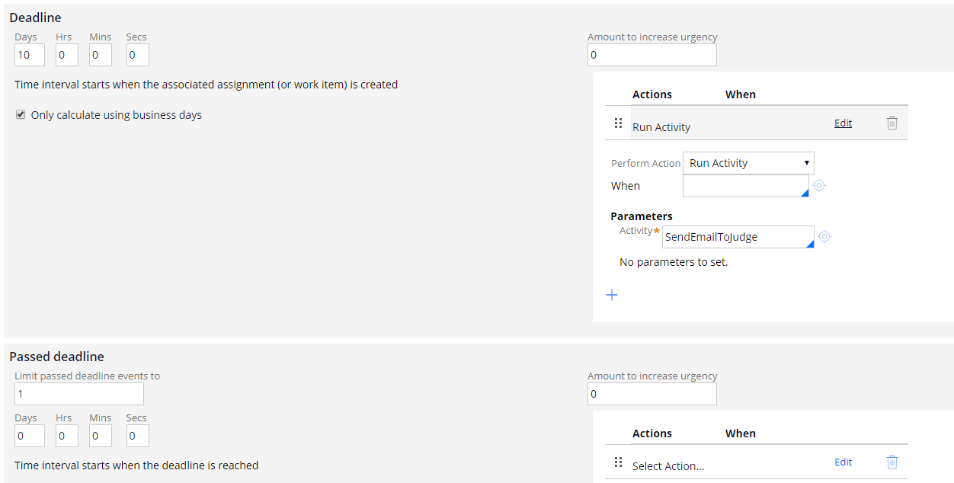

1. Add Service Level Agreement on Investigation Process Flow, open the Investigation assignment shape and add this SLA. check below image for the same.

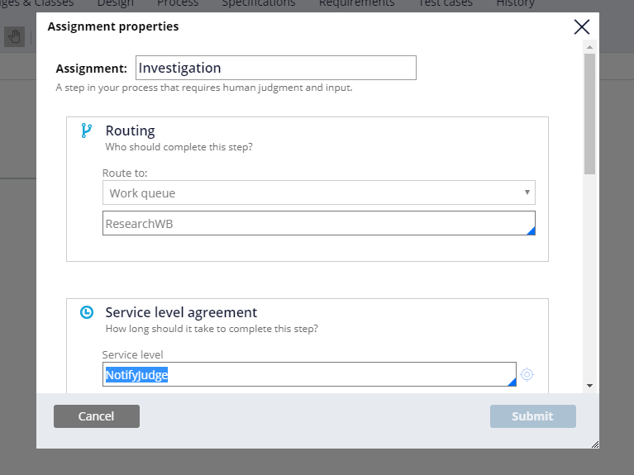

## 8. Activity

**I. CheckPledge activity**

1. Go to App Explorer, **Right-click on MinistryOfJustice > Create > Technical > Activity**

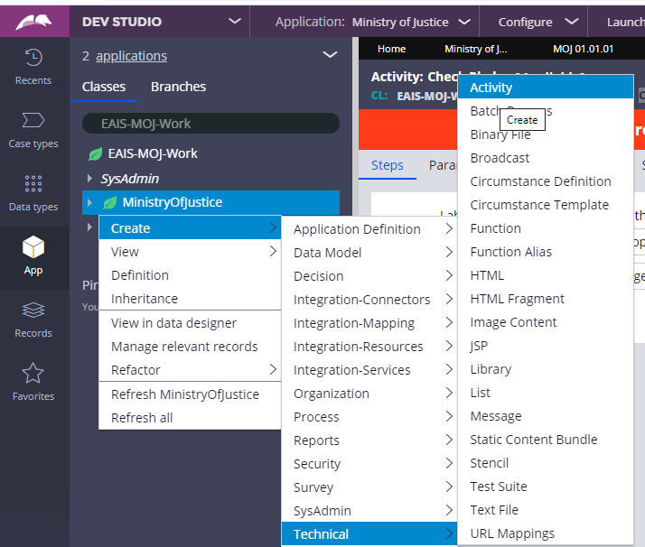

1. Give label **CheckPledge,** Class: EAIS-MOJ-Work-MinistryOfJustice, Ruleset: MOJ, Version : 01-01-01, then click on Create and open.

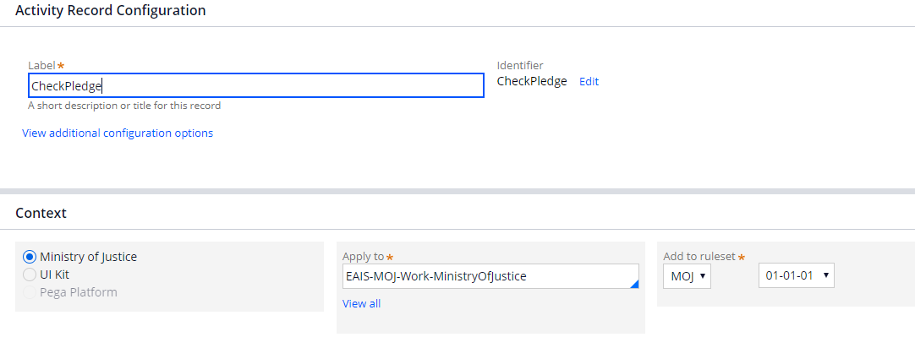

1. For this activity to work, prerequisites to create When rule and Message rule
2. Create when rule, in Class EAIS-MOJ-Work-MinistryOfJustice, Ruleset: MOJ, Version: 01-01-01

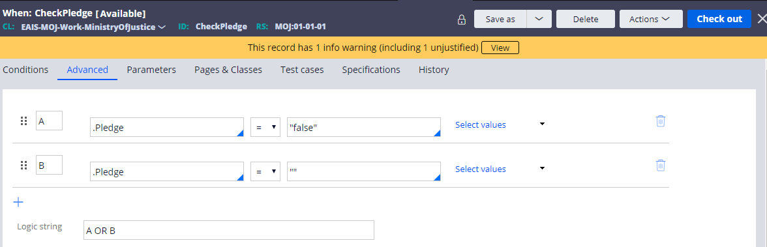

1. Create Message rule , in same class and ruleset version, by going Create menu> Technical > Message

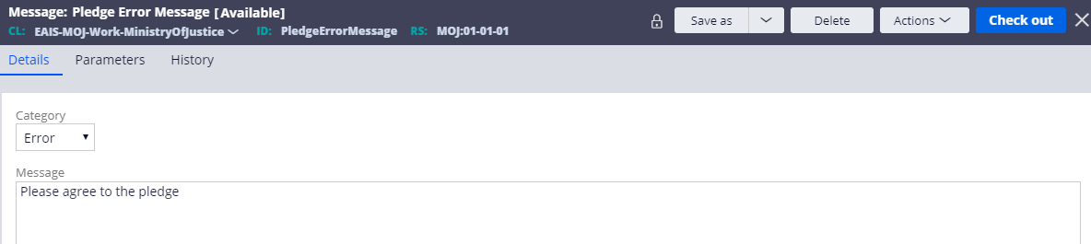

1. Now configure the Activity,

Step1: Add Page-Set-Messages, and enable when condition and add when rule, CheckPledge, Please follow the below image to configure if missed something.

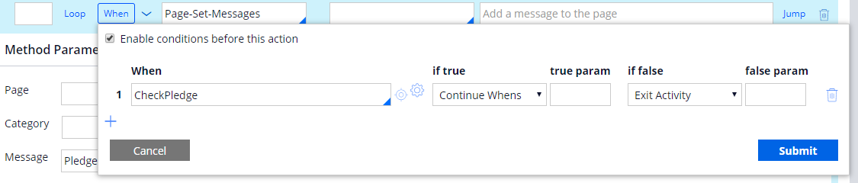

Also add, Message rule, **PledgeErrorMessage** by pressing the down arrow key.

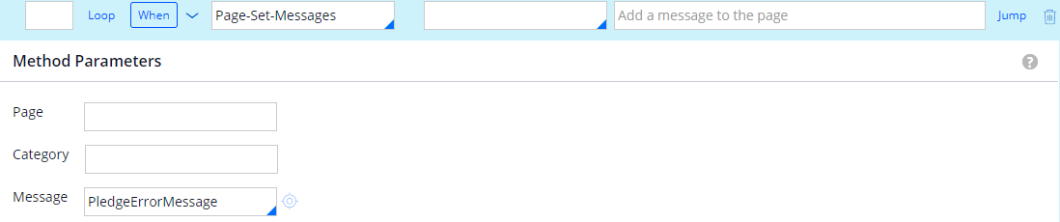

1. Apply **CheckPledge** Activity, in PerformUndertaking Flow Action, under Action tab in Post-processing section

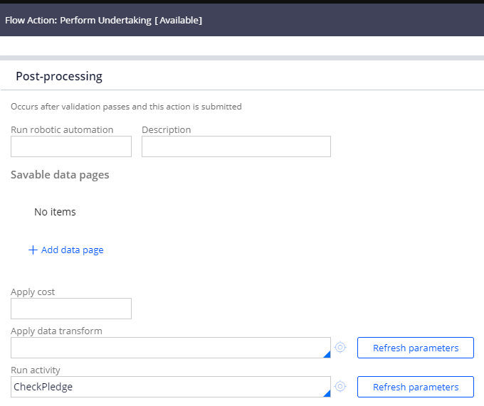

**II. FetchCaseDetails** Activity:

Create FetchCaseDetails activity in class EAIS-Int-FetchCaseDetails, Ruleset: MOJ, Version : 01-01-01

**Step 1**: In Pages and Classes tab, enter Page name: MyServicePage and class: EAIS-Int-FetchCaseDetails

In the Steps tab, select Property-Set-Messages from the list, Step page: MyServicePage, Description: Set the error message when case number is null

Also enable the When rule, and configure .CaseNumber==””, Continue Whens if true else Jump to later step A.

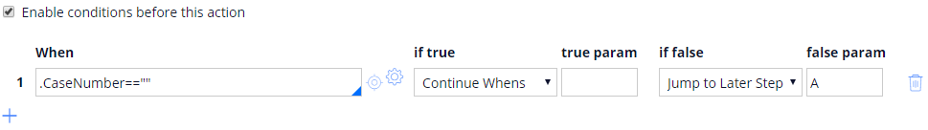

Also in the Message field, enter “Case Number is Mandatory”, in the Field , enter .CaseNumber.

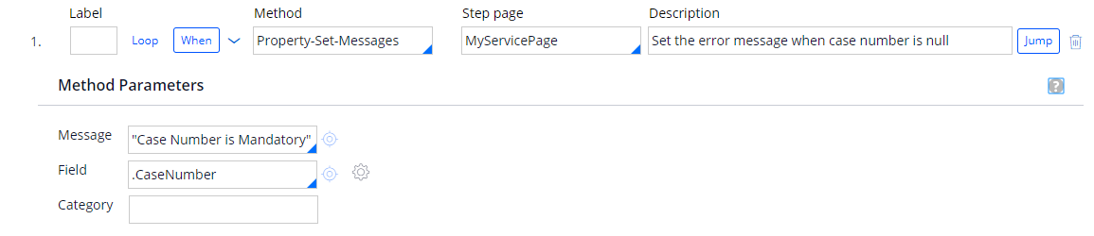

Enable Jump condition as well and specify when true, Exit Activity, if false Jump to Later Step A

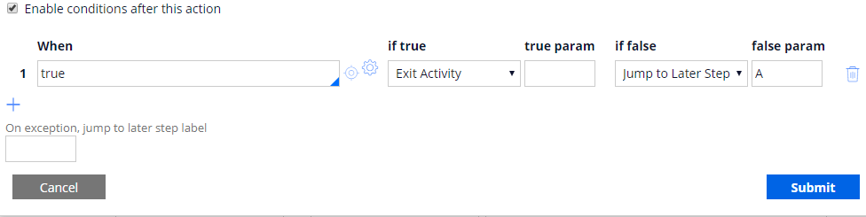

**Step 2:** Add label as A. Select Property-Set from the list, Step page: MyServicePage, Description: Set Param.CaseNumber for getting case information.

Enable When condition and specify the condition as below.

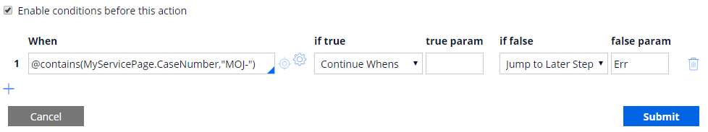

Add Method Parameters:

Param.CaseNumber equal to .CaseNumber

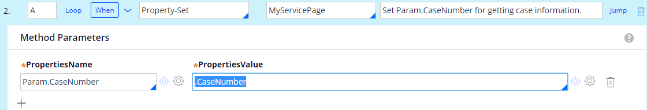

**Step 3**: In Pages and Classes tab, Specify Page name: CaseDetailsPage, Class: Code-Pega-List, Add other Page name, CaseDetailsPage.pxResults and class as EAIS-MOJ-Work-MinistryOfJustice

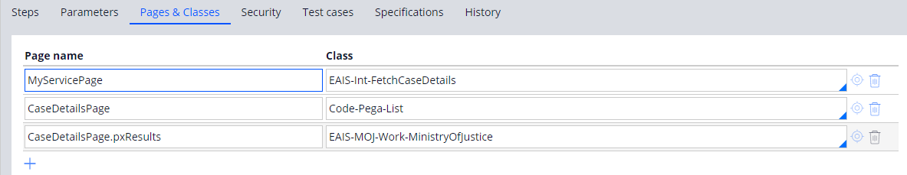

In Steps tab, Select **Obj-Browse** from the list, Step Page: CaseDetailsPage, Description: Fetch the particular case information.

Add Method Parameters,

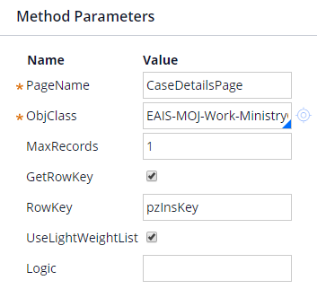

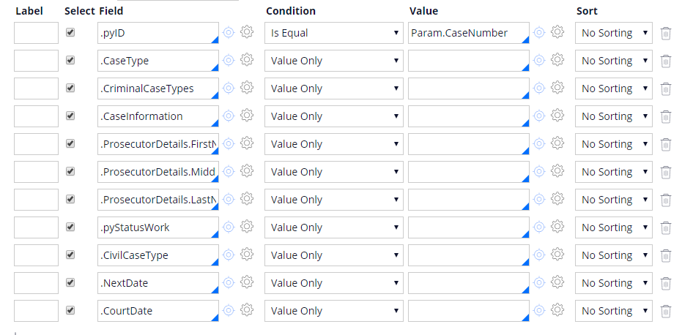

**Step 4:** Select Property-Set from the list, add StepPage: MyServicePage, Description: Set the response in the service page. Add Method Parameters,

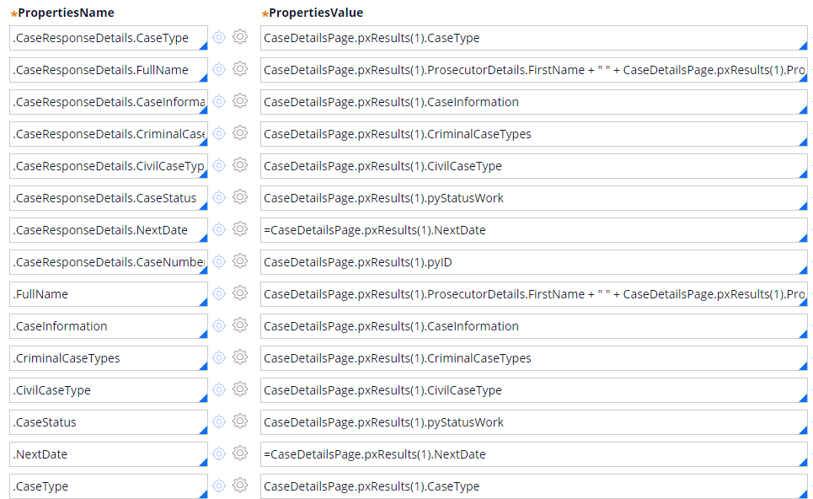

Enable jump condition, when true, Exit Activity, if false, Continue Whens.

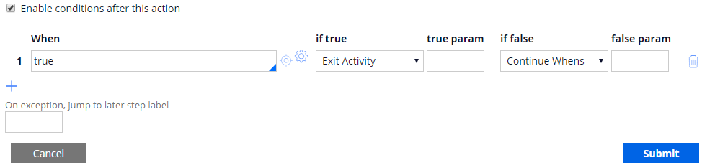

**Step 5:** Add Label Err, Select Page-Set-Messages from the list, Description: Add a message when Case number is not valid, Add Method Parameters: Enter Message as "Please Enter a Valid Case Number"

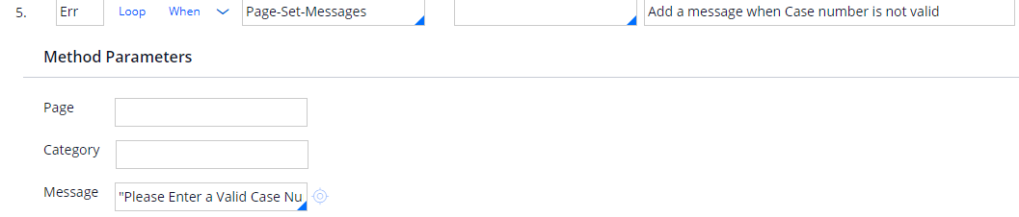

Now click on Save and Check-in the rule by adding some comment in it.

## 9.Test your work:

|  |  |
| --- | --- |
|  | Verify the work you have done. |

1. In the **Designer Studio**, go to the **Case Type** explorer and select your case type name.
2. Now click on the **Save and run** button given to the right corner to run your case type.

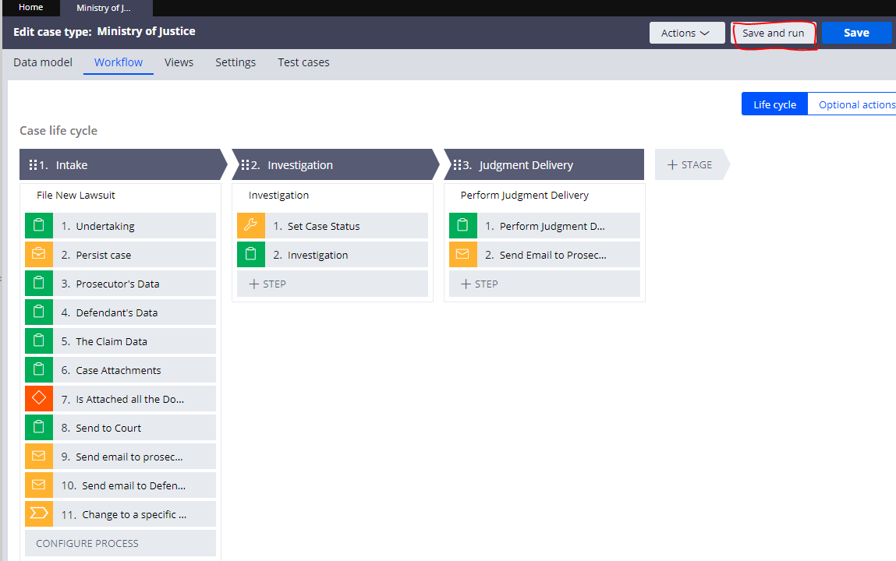

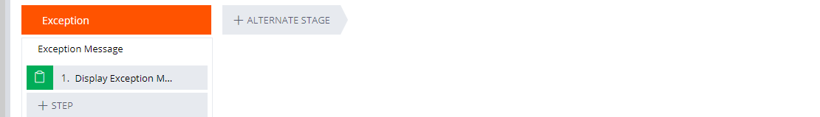

1. In this screen, accept the undertaking form and click on continue to proceed ahead

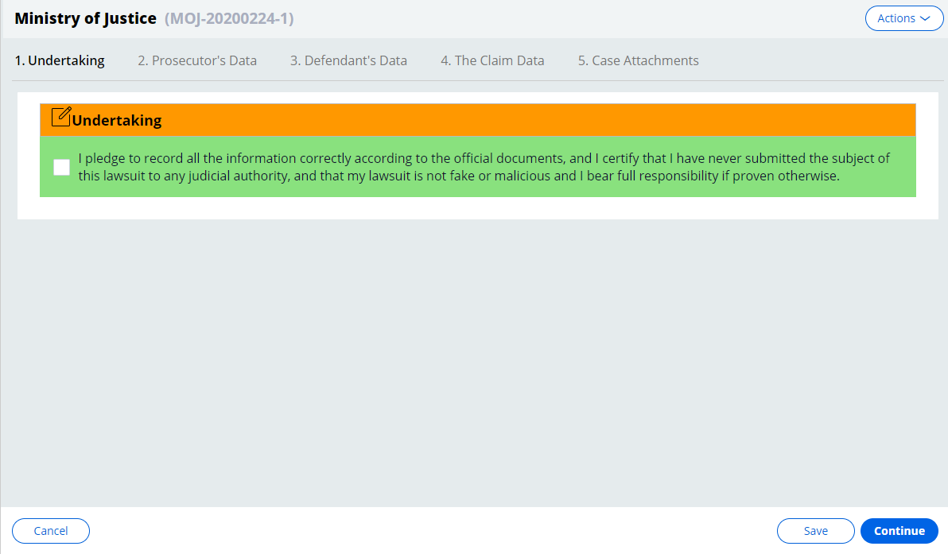

1. Fill the Prosecutor’s data, defendant data and Claim data, and click on Continue

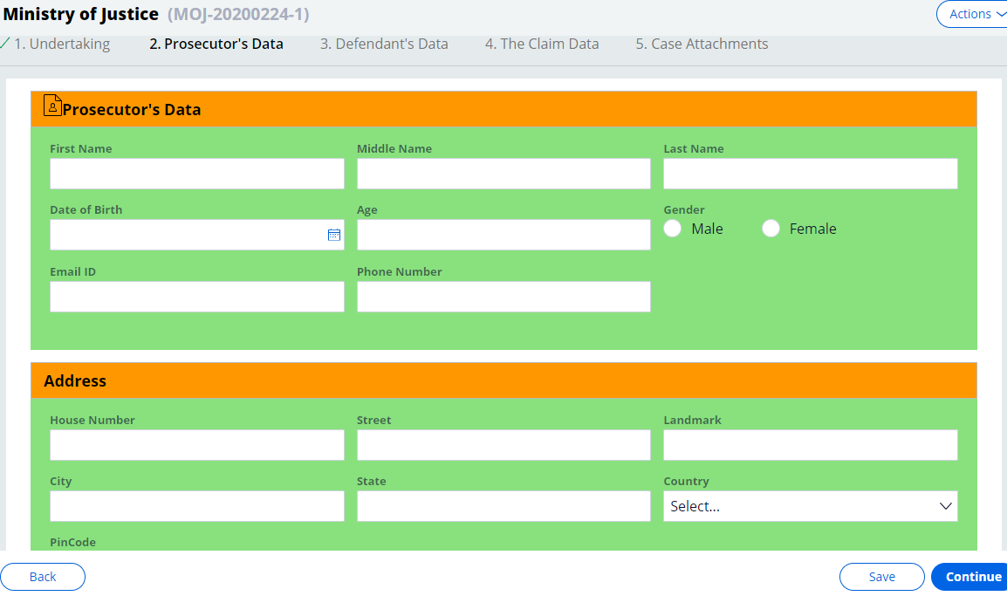

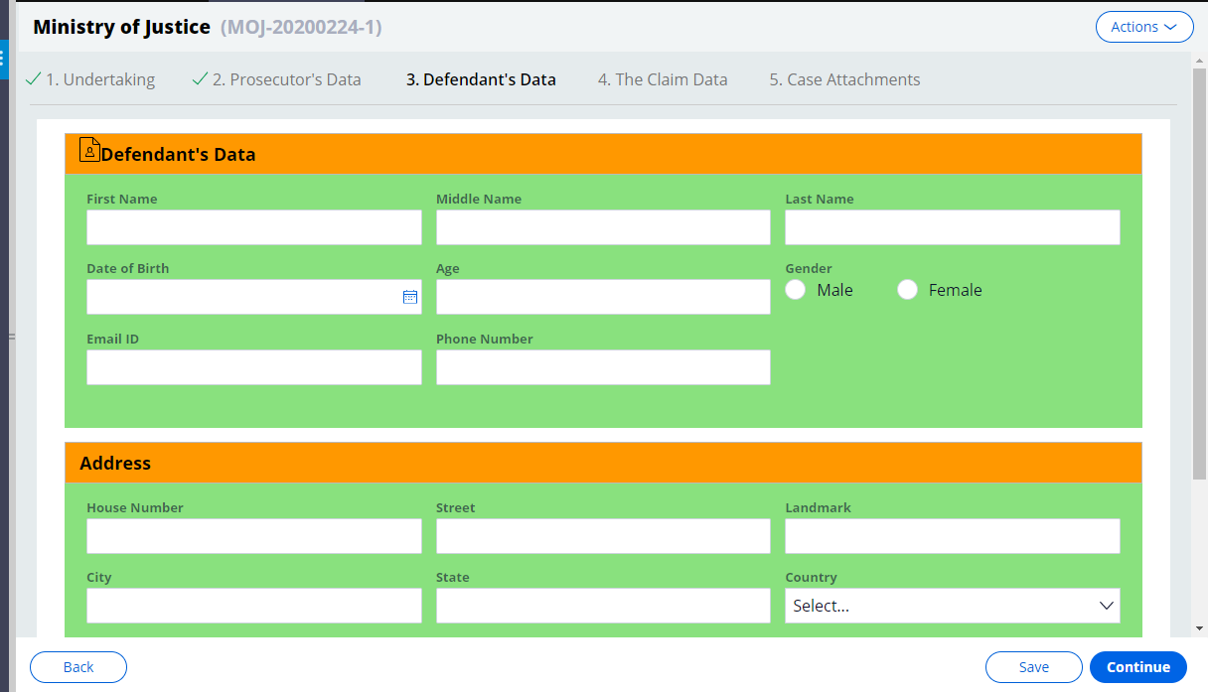

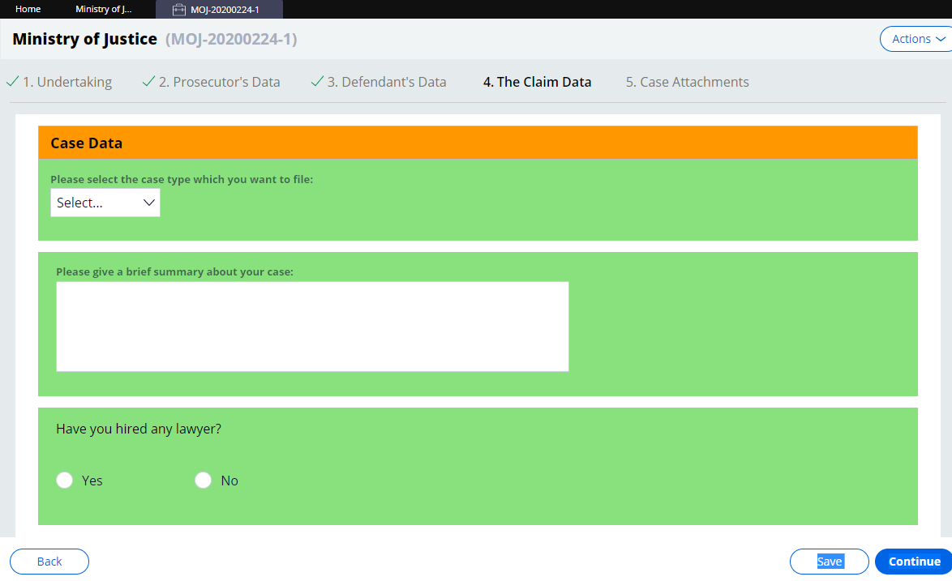

1. Now upload the required attachments,

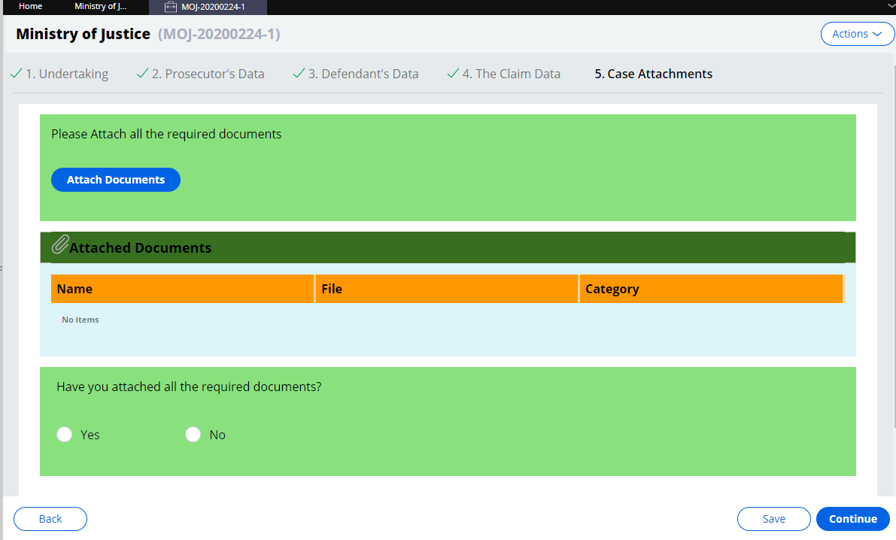

1. Once all required documents are uploaded, it will send to court, also provide you a date to be available in the court, then click on Finish.

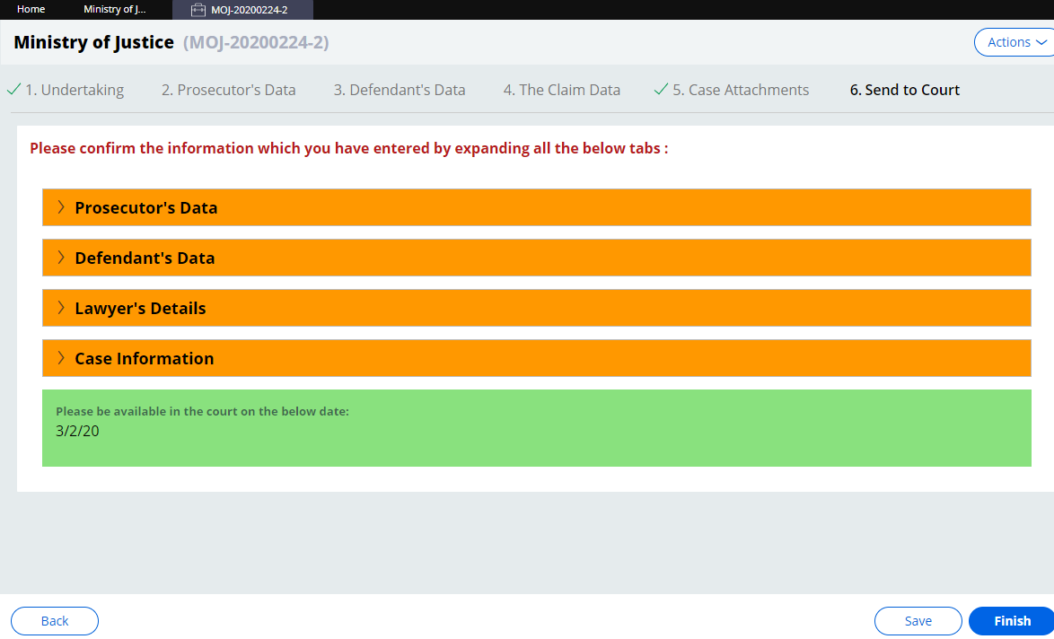

1. Once you click on finish, one email will be sent to you regarding your presence in the court.
2. Now click on Investigation to start, from the Actions Menu,

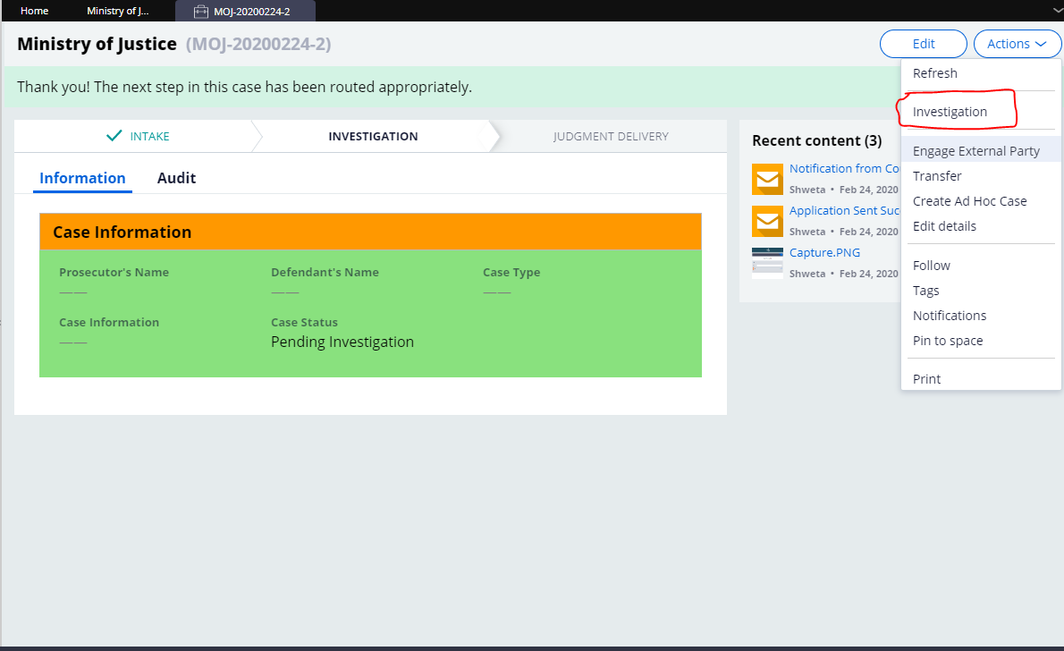

1. Now your case is in Investigation stage, click on submit

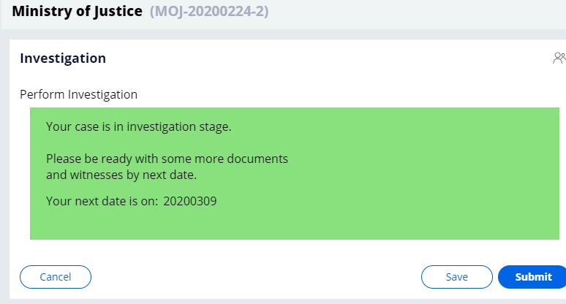

1. From the Actions menu, click on Judgement Delivery,

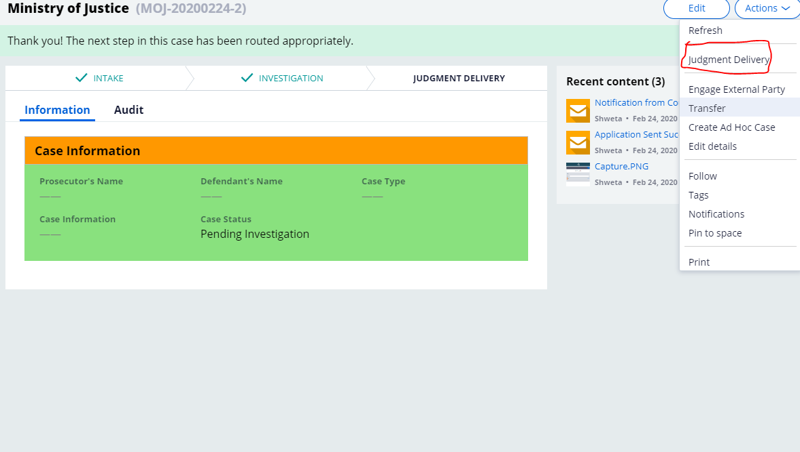

1. Now you are under Judgement Delivery stage,

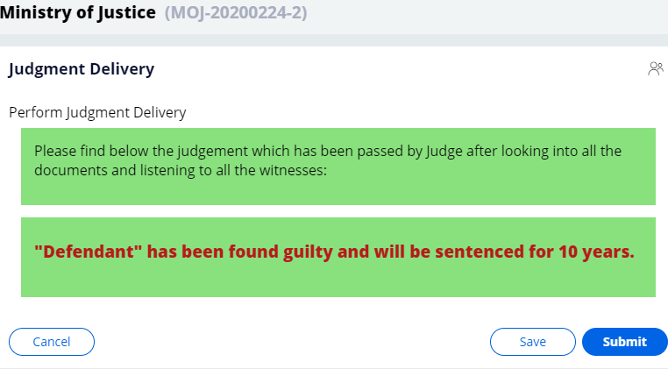

1. One email will be sent to you, regarding whatever Court order will be.